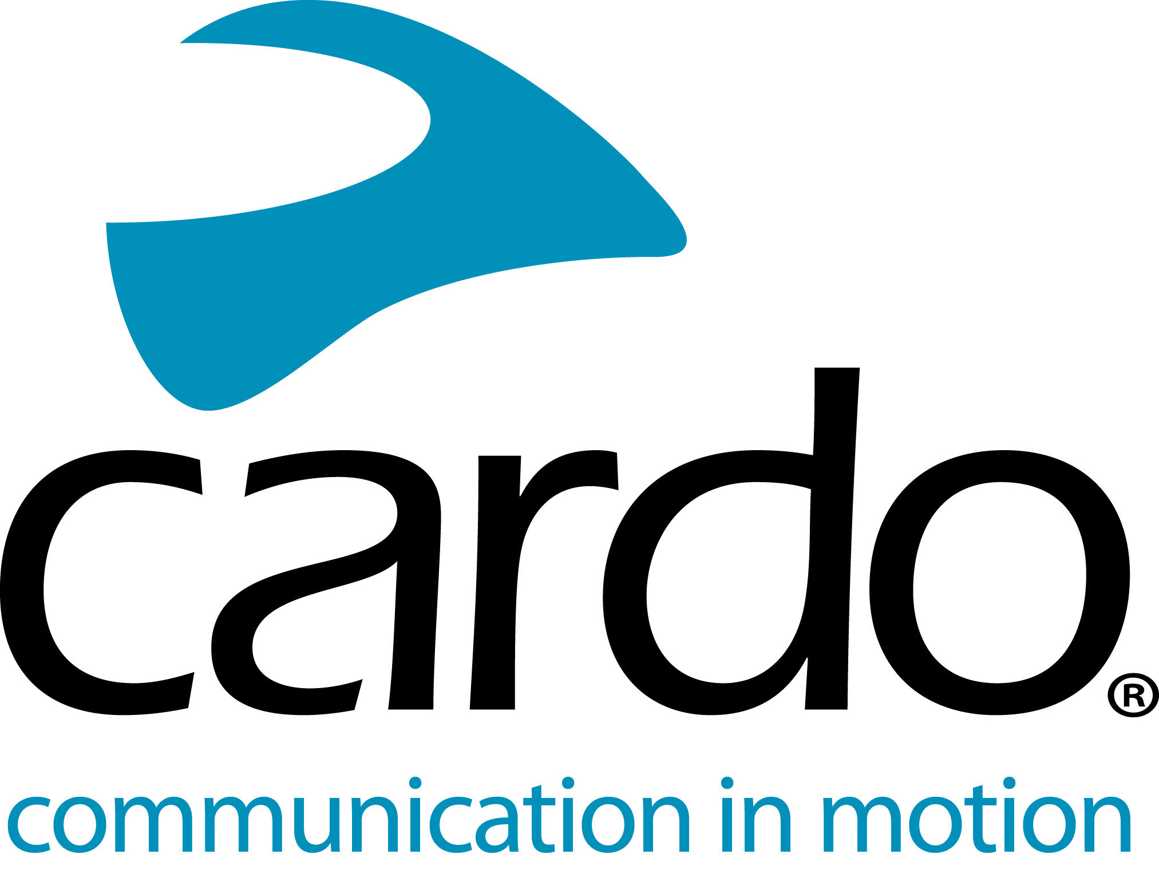

Round the world with Cardo Systems’ PACKTALK Bold
30,000kms. 23 countries. Two PACKTALK Bold devices. Six months.
In July 2020, Lennart Andreas and Maia began an extraordinary adventure - navigating their way around the world on Triumph Tiger 900 Rally Pro motorcycles, all while adhering to the quarantine restrictions of a global pandemic. Their choice of communications device for the trip? Cardo Systems PACKTALK Bold…
“We have used communications systems in the past but have grown frustrated with battery issues, losing connection and uncomfortable headphones. Often, we’d end up totally annoyed because we couldn’t understand each other and the units didn’t do what they were supposed to. All of this was solved when we switched to Cardo! It’s a great product that just works.”, said Lennart.
After initially being told about the Cardo System devices when visited by two friends - Asta and Linas - who were travelling the world in 2018, Lennart and Maia decided to trial the Cardo units for their epic tour which took them to the most northern point of Europe and most southern point of Africa.
“Being able to share what you see while you’re riding and experience it with one another, making every moment more intense and memorable. There is also the safety aspect - it is much safer when using the units as you are able to warn each other of any dangers in the road, which is especially handy when travelling on uneven terrain. We found ourselves in some situations which were physically and mentally challenging - having the chance to motivate each other was probably the reason we have made it to the end safe and sound.”
Having a communications device that they could communicate with each other reliably made their experience ‘much more complete’.
“The battery life is fantastic - the ability to charge it on the go is another plus. Little things, like the fact the device warns us of a low battery around two hours ahead and not just a few minutes before it shuts down, can make the world of difference.
“For me, it’s the range and reliability, even at higher speeds. We can still understand each other without getting frustrated and the voice commands [Natural Voice Operation] make accessing functions easier - and even fun! We both love to say “Hey Cardo, let’s rock. When we were riding in cities, we encountered bad traffic situations where it was safer and easier to use voice commands and still be riding the bike with both hands on the bars."
Lennart and Maia experienced a wide variety of conditions while on their trip - the dust and waterproof Cardo didn't let them down.
“No matter the conditions, the Cardo product just works. We got snow storms, 40 degrees Celsius, torrential rain, sand storms - no matter what we encountered, no matter how tough the conditions were, the Cardo kept on working.”
One benefit of Dynamic Mesh Communication (DMC) connectivity - featured on the PACKTALK range - includes the ease of linking additional units - a process that can be done in under 10 seconds.
“We managed to visit Asta and Linas in Lithuania - and as we all had Cardo units, it was simple and easy to connect our units and head out on a ride. No need to struggle or go through a million menus - push a few buttons and get riding. We enjoyed a great city tour!”
A final word from Lennart to riders who haven’t tried a Cardo System yet?
“Give it a try. I think many riders underestimate the added value of being able to communicate with others while riding. You don’t have to talk all the time - but there are many occasions when it comes in handy and offers a whole new dimension to riding motorcycles together. To be able to share everything that we saw as we went through all these countries was priceless.”
Find out more by visiting www.cardosystems.com or head to your local Cardo Systems stockist.
Join the conversation on Facebook, Twitter, Instagram and YouTube.
Keep up with the adventures of Lennart Andreas and Maia by finding them on Instagram: @lennart.andreas and @maias_travels or following them on Facebook here.
About Cardo
Cardo Systems specialises in the design, development, manufacturing and sale of state-of-the-art wireless communication and entertainment systems for motorcycle riders. Since inception in 2004, Cardo has pioneered the vast majority of innovations for Bluetooth motorcycle communication systems. The company’s products, now available in over 100 countries, are the world’s leading communication devices for the motorcycle industry.

