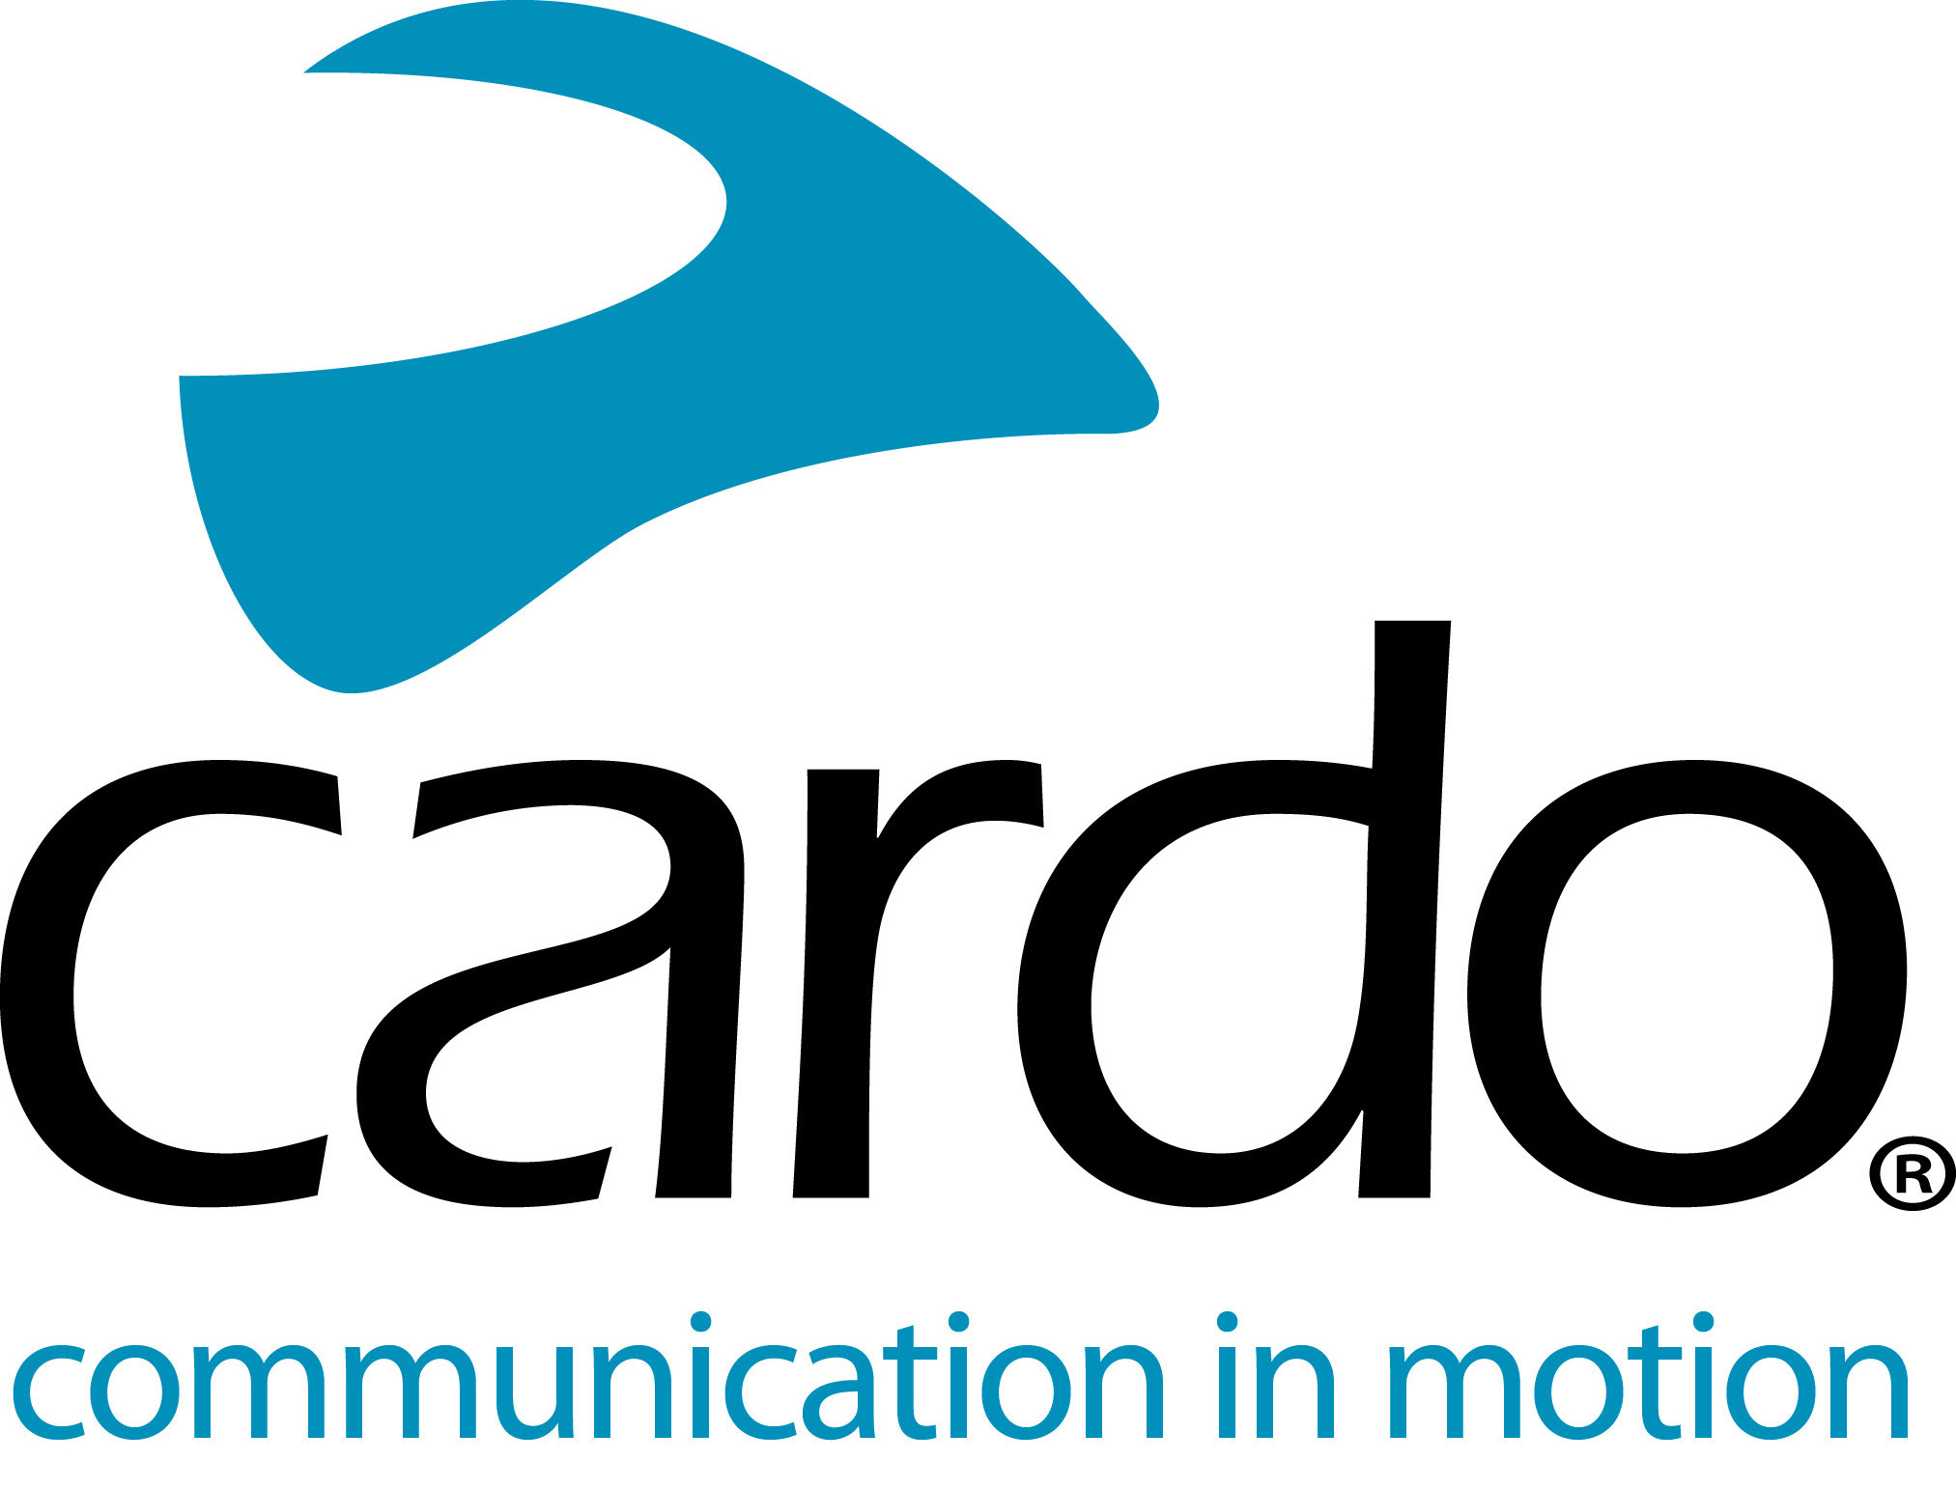

Introducing the #CardoFam: Off-road legend, Chris Birch
Eight-time New Zealand Enduro overall champion, three-time Roof of Africa winner, regular competitor in many the world’s biggest enduro racers and seven-time podium position finisher at Red Romaniacs, it’s fair to say that for many riders, Chris Birch needs no introduction.
As well as having extensive riding experience, Chris’s background as a mechanical engineer gives him the skill to break down the physics of riding to easily understandable chunks, making his off-road riding skill schools popular across the world. It’s at these schools where he uses Cardo Systems to help communicate with his students.
The reliable Dynamic Mesh Communication connectivity allows up to 15 riders to be connected at one time and the ‘set-and-forget’ functionality of the system means Chris can do just that. Plus, due to the mesh connection, riders can swap and change positions as much as they like, without connectivity being lost - essential at an off-road tuition day.
He explains: “The Cardo units impressed me from day one. As soon as I switched them on, they just worked. What I really liked was the fact there was no messing about connecting and reconnecting once they’d been paired. We just switch them on and ride.
“When using the Cardo units coaching I can give instant feedback to my students. This allows them to progress noticeably faster and with more safety. Because the Cardo is simple to use and stable, it adds to the day without causing distraction.”
It’s not just coaching when Chris uses the Cardo Systems PACKTALK Bold unit, his seven-year-old daughter is also a big fan.
“I use it all the time now - whether it's coaching, riding with friends or riding with my family. Having the ability to clearly and easily communicate whilst riding makes things so much safer and a lot more fun actually.
“Being able to talk with my daughter Zoe whilst riding has been a game-changer. She is quite new to riding and being able to talk with Dad has given her a huge confidence boost. We can now go places together that we never would have been able to before. Listening to her laughing and playing games as we ride is awesome. She now wants to ride her bike more and won't ride without the Cardo.”
When not teaching or riding with his daughter, Chris is out riding with friends. The range on the PACKTALK Bold units is up to 1600 metres in perfect conditions, which means everyone can ride at their own pace and still stay connected.
“Having us all linked together and able to easily communicate makes the whole ride flow better than when we don’t wear the units. They mean that we don't have to stop to check on each other and when we roll into town we’ve already decided where we are going for lunch.”
You can find Chris on Instagram, Facebook and YouTube, and find out more about his off-road coaching by visiting www.chrisbirch.co.nz.
Join the conversation and the #CardoFam on Facebook, Twitter and Instagram.
About Cardo
Cardo Systems specialises in the design, development, manufacturing and sale of state-of-the-art wireless communication and entertainment systems for motorcycle riders. Since inception in 2004, Cardo has pioneered the vast majority of innovations for Bluetooth motorcycle communication systems. The company’s products, now available in over 100 countries, are the world’s leading communication devices for the motorcycle industry.

