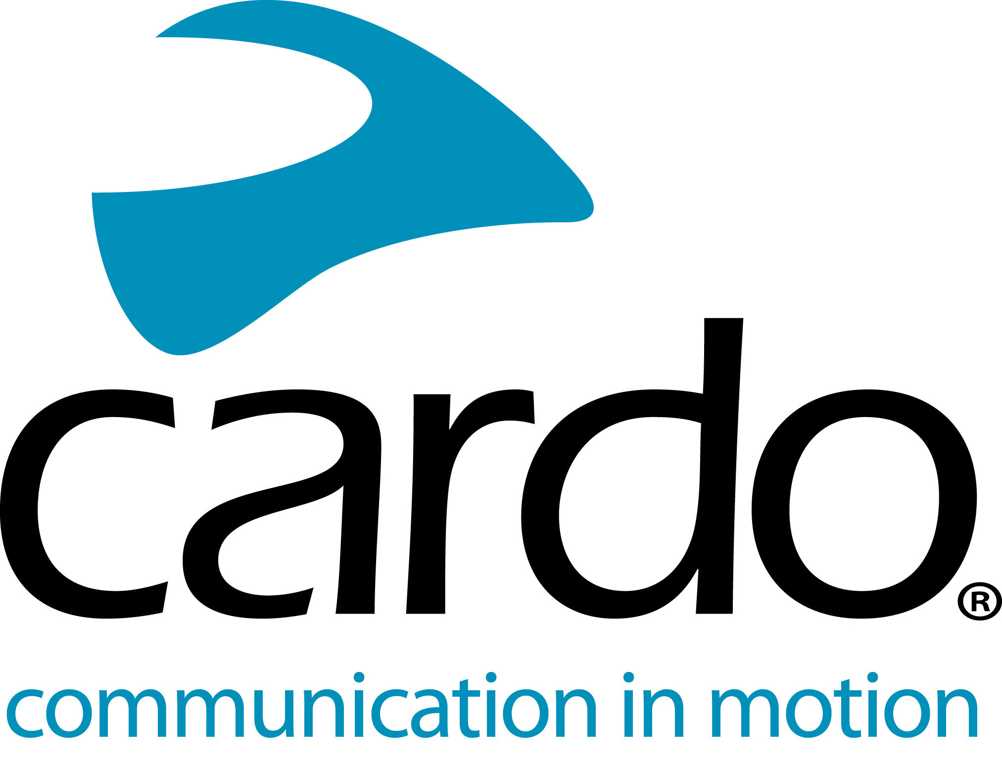

Filming off-road and communicating with Cardo Systems
With 150,000 subscribers, 70 million video views and a whole raft of clients to keep happy, the pressure is on for Max Hind, owner of Toofast Media Group, to produce high-quality video content. Specialising in the motorsport, action sport and two-wheeled sector and running one of the biggest dirt bike focussed YouTube channels - 999lazer - the requirement to upload regular content is non-stop. Something Cardo Systems is proud to help with…
“Cardo Systems has transformed the way I work with my team when we’re filming. We use Cardo to communicate with each other on almost all our projects now. The ability to talk to my drone pilot, camera guys and rider - all while the action is happening - is a huge benefit from a director’s point of view.” admits Max.
Using up to eight waterproof and dustproof Cardo Systems PACKTALK Bold devices at one time and connecting via the Dynamic Mesh Communication means that all the team members can talk with each other effortlessly and don’t need to worry if anyone moves in and out of the five mile* range - as they automatically reconnect. Up to 15 devices can be paired at and used at one time, meaning Max’s team can grow even further. Utilising Cardo’s demo headphone set-up, the team are available to simply click in a device and use it without a helmet.
“The fact that there are no buttons to press to speak - like you have to on a traditional walkie talkie - means that our hands can stay on the cameras. We also have the capability to record the conversations between the rider and/or the camera team and use the audio in our films - which is a really cool addition. They’re the whole package - amazing range, ease of usage and fantastic audio quality from the JBL speakers. When we first started using them, they blew us away.”
The PACKTALK Bold even has the team covered for the often long hours that come with video shoots, with 13 hours of battery life on just one charge. However, by using the Cardo units, filming days are more efficient for the team.
“Without communication with the rider, we had to stop riders to give them instructions, which cost us valuable time and can also disrupt the overall flow of filming. Riding off-road, riders can take a while to get into a rhythm, so even making a small change can have a knock-on impact on the shoot. With the Cardo, we simply make the suggestion and then the rider can action it on the next pass straight away - and stay in their rhythm.”
To find out more about the Cardo Systems line-up, visit www.cardosystems.com or contact your local distributor – www.pama.com/cardo
To join the conversation, follow along on the Cardo Systems Facebook, Twitter and Instagram channels or check out the YouTube channel.
Photo credit: Toofast Media Group
About Cardo
Cardo Systems specialises in the design, development, manufacturing and sale of state-of-the-art wireless communication and entertainment systems for motorcycle riders. Since inception in 2004, Cardo has pioneered the vast majority of innovations for Bluetooth motorcycle communication systems. The company’s products, now available in over 100 countries, are the world’s leading communication devices for the motorcycle industry.

