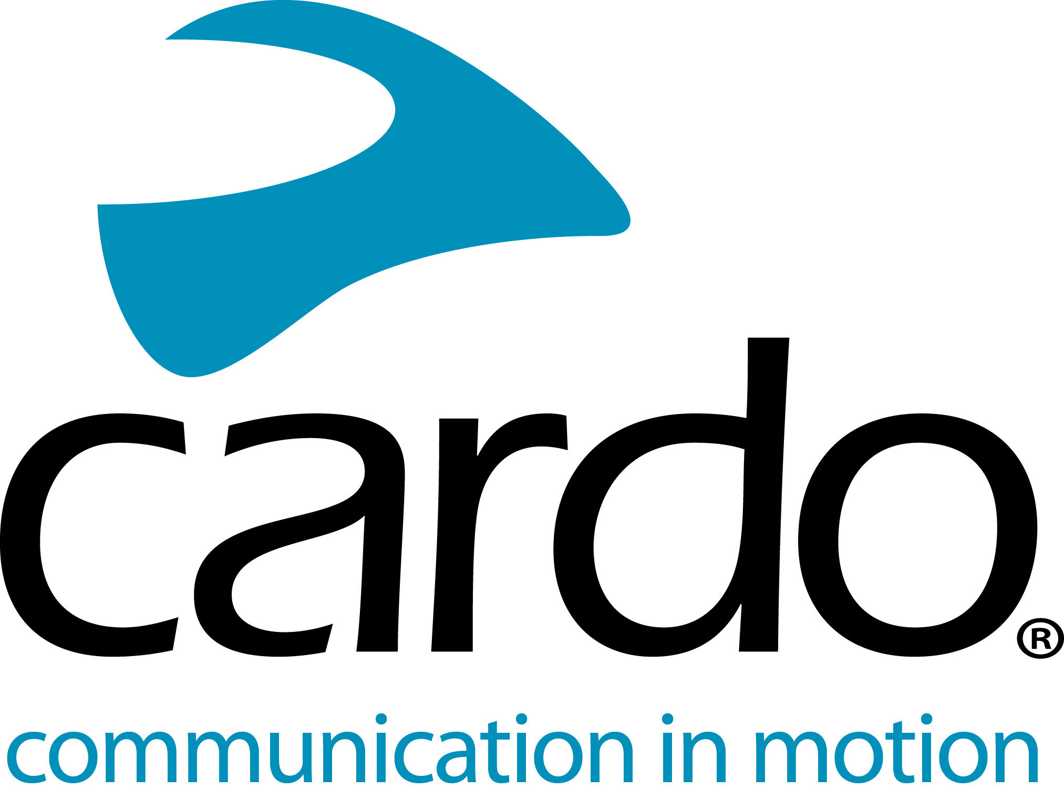

Dynamic Mesh Communication from Cardo Systems
Cardo Systems were the first to go beyond Bluetooth in wireless motorcycle communicators when it introduced Dynamic Mesh Communication (DMC) in its PACKTALK units in 2015. Forward on five years and Cardo Systems have refined this technology even further - here are more details as to what it is and what it means for riders - whether riding alone or in a group…
What is it?
Bluetooth works by making a straight-chain - the more riders involved, the weaker the chain has the potential to be as if one link in the chain disappears, the connection line is broken. Dynamic Mesh Communication is, as the name would suggest, a flexible network made up of many different connections between each unit. Each DMC unit acts as its own communications hub, constantly searching to connect with other units it ‘knows’. This fluidity of the mesh means that riders can change positions, join the group or leave and come back later.
Why does it matter?
- Quick pairing
Pairing your unit with others in MESH mode can be done in six seconds. Experience seamless and reliable communication quickly and effectively.
- Set-and-forget self-healing network
Dynamic Mesh Communication connectivity allows riders to ‘set-and-forget’ when pairing their units with others and with devices to experience 'Always On' Intercom. Whether moving in and out of range on a ride or not riding together for months - once paired, the riders don’t need to reconnect as it’s done automatically, without the need to press any buttons.
- High-quality connection
DMC provides a reliable connection - should one device drop out, perhaps due to a dead battery, it won’t compromise the other connections.
- Full Audio
Whether it's music and intercom, a phone call and the radio - know that all the audio sources are intelligently mixed without you needing to worry about anything.
- Single and Group Riding
Enjoy unparalleled communication from group riding with a little as two members. The range between each DMC unit is up to one mile (1.6km) and up to five miles (8km) across the whole group - plus the ability to connect two to 15 riders on one ride. Ride your own ride, without the worry of riding in and out of range.
The DMC technology can be found in Cardo Systems’ top of the range products, the PACKTALK BOLD, PACKTALK BLACK and PACKTALK Slim. Offering a ‘best on the market’ experience, each unit not only offers exceptional connectivity, but class-leading sound quality thanks to JBL speakers, increased range of up to 1 mile (1.6km) and Cardo’s very own voice activation technology also.
Win one of three PACKTALK Bold duo kits up for grabs from Cardo Systems by clicking here.
Thinking of joining the #CardoFam? Visit www.cardosystems.com or visit your local Cardo Systems stockist for more details and to find out more.
Join the conversation on Facebook, Twitter, Instagram and YouTube.
About Cardo
Cardo Systems specialises in the design, development, manufacturing and sale of state-of-the-art wireless communication and entertainment systems for motorcycle riders. Since inception in 2004, Cardo has pioneered the vast majority of innovations for Bluetooth motorcycle communication systems. The company’s products, now available in over 100 countries, are the world’s leading communication devices for the motorcycle industry.
For press enquiries:
press@cardosystems.media | www.cardosystems.com

