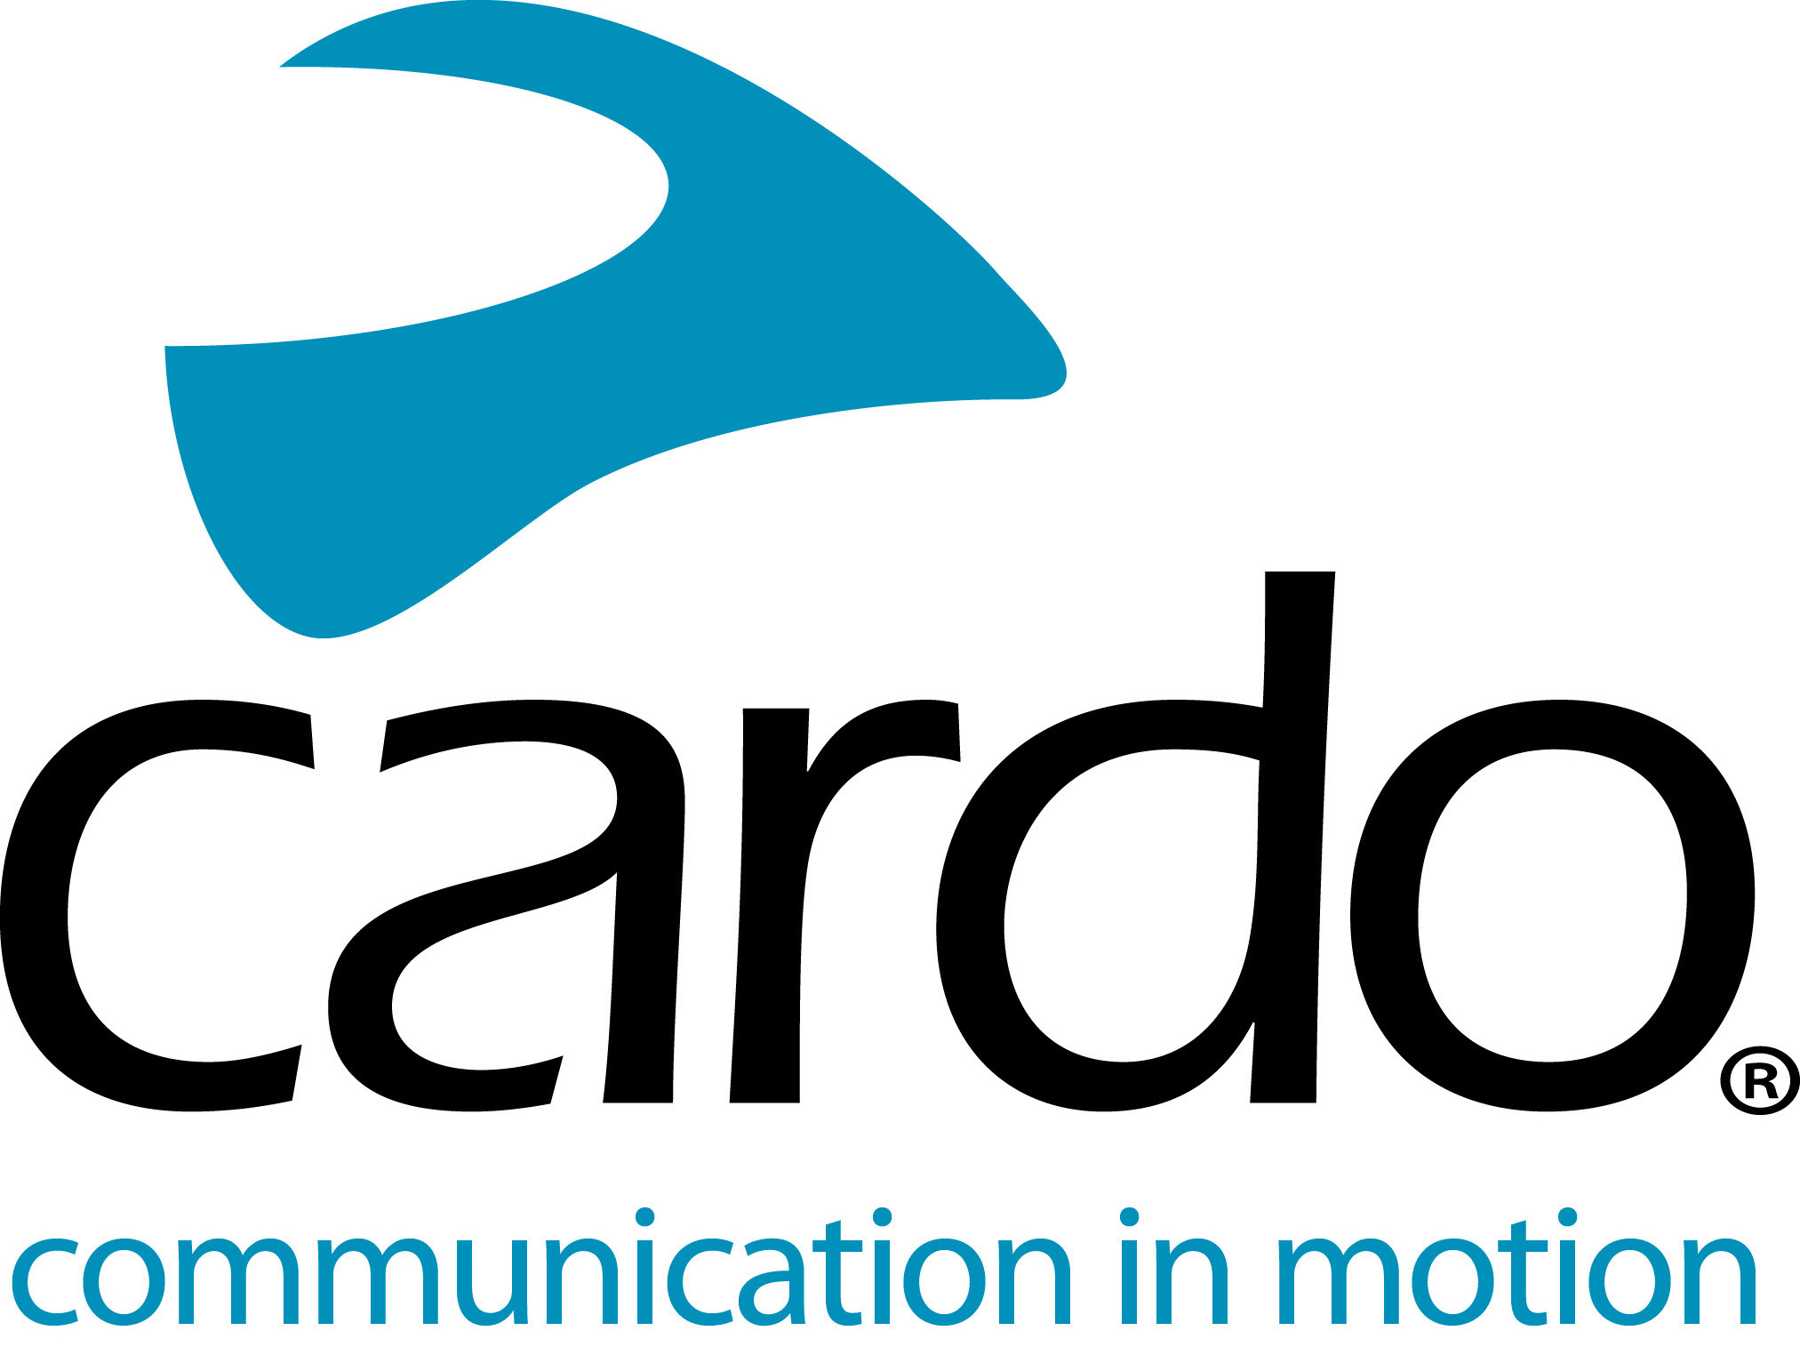

Celebrating 15 years of wireless communications systems with Cardo Systems
Since pioneering the motorcycle Bluetooth market in 2004 with the ‘Scala Rider’, Cardo Systems has become a global market leader in wireless communications systems designed specifically for motorcyclists.
Dr. Abraham Glezerman, Founder and CEO of Cardo Systems says: “This has been a tremendous ride. When we first developed our original Bluetooth earpiece into a motorcycle communication system, we knew we were on to something, but what we didn’t know it would grow this big - we created a whole new market. Reflecting back on the past 15 years, we are extremely proud and I believe the next 15 years will be just as exciting!”
To celebrate its 15th anniversary, Cardo Systems has announced its latest joint development with JBL, allowing customers all over the globe - with communicators of any brand equipped with a standard 3.5mm audio jack - the ‘Ultimate Sound Experience’. The Cardo 45mm Audio Set is priced at $89/€89 and available directly from www.cardosystems.com as well as distributors worldwide.
Originally founded in 2002 as a developer and manufacturer of Bluetooth earpieces for mobile phones, Cardo Systems entered the motorcycle market in 2004, with the very first Bluetooth unit, the ‘Scala Rider’. Since then the company has been focusing on ‘making the lives of our fellow riders better’ and has been committed to that ever since. On this 15-year pursuit, Cardo has achieved numerous world firsts, including:
2004: World’s first motorcycle Bluetooth headset
2005: World’s first built-in FM radio and automatic volume control
2007: World’s first rider-to-ride intercom - with a range of 700m/0.45mi
2009: World’s first long-range intercom and first to offer internet firmware upgrades
2012: World’s first music sharing
2015: World’s first ‘Mesh’ device - the first motorcycle communicator to go beyond Bluetooth and introduce Dynamic Mesh Communication (DMC) - https://youtu.be/8ef8D8IiVNY
2018: World’s first Natural Voice Operation with direct access to ‘Hey Siri’ and ‘OK Google’
2019: World’s first embedded premium audio system in partnership with JBL.
The complete Cardo range is developed to be IP67 waterproof - so riders can be sure that no matter what the weather, they can rely on their Cardo unit.
The entire FREECOM+ and PACKTALK ranges can be controlled using Cardo’s new mobile app, Cardo Connect™. Free to download, the app has been designed for a smooth user experience and shows a dashboard of information associated with the connected Cardo device. Users can create ‘groups’ of riders, manage their favorite radio stations, configure phone speed dials, control settings, adjust volumes and see the units battery status at a glance.
For more information and to see the whole product range, visit Cardo Systems at www.cardosystems.com and join the conversation on Facebook, Twitter and Instagram.
About Cardo
Cardo Systems specialises in the design, development, manufacturing and sale of state-of-the-art communication and entertainment systems for motorcycle helmets. Since inception in 2004, Cardo has pioneered the vast majority of innovations for Bluetooth motorcycle communication systems. The company’s products, now available in over 85 countries, are the world’s leading communication devices for the motorcycle industry.
For press enquiries:
For more information, high resolution images or interview requests, please contact press@cardosystems.media

