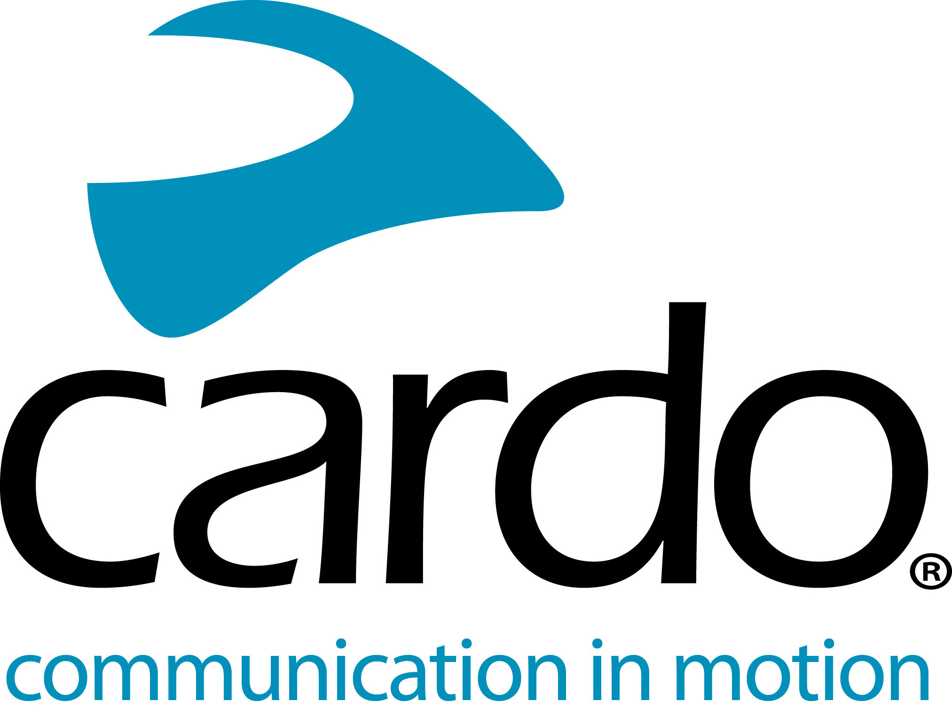

Cardo unveils the all-new PACKTALK generation - The PACKTALK EDGE. Greatness. Reborn.
Following extensive research and development, and a complete overhaul of the entire component make-up of the PACKTALK series, Cardo Systems is proud to announce a new generation of the world’s best motorcycle communications system, the all-new PACKTALK EDGE.
Key highlights include:
- New slim modern design with no external antenna
- New magnetic Air Mount for effortless and secure attachment of unit to helmet
- Second-generation Dynamic Mesh Communication with faster and easier pairing process and wide-band intercom
- Most advanced Bluetooth 5.2 Technology with „Live Intercom“ support and improved universal connectivity
- Upgraded Natural Voice engine, enhanced JBL Sound, improved noise-cancelling microphone
- Additional new features include over-the-air software updates and fast charging via USB-C.
The new small, slimline, antenna-free unit, has been completely redesigned, boasting a whole host of new features as well as benefiting from all the user-favourite attributes of the previous generation, to make the world’s best motorcycle communications device, even better.
In 2015, Cardo Systems launched the world’s first motorcycle communicator to go beyond Bluetooth, with its introduction of Dynamic Mesh Communication (DMC). The state-of-the-art technology means the devices function with a self-adjusting network that not only automatically maintains a connection between up to 15 riders, but allows them to seamlessly join, leave and rejoin at a distance of up to eight kilometres (five miles). The PACKTALK EDGE takes this technology one step further and boasts second-generation DMC connectivity with benefits including: an unparalleled deep wideband sound quality, a simpler and faster grouping process in DMC mode, faster pairing in Bluetooth mode, and Live Intercom Bluetooth support.
Helping cement its ‘edge’ over its predecessors, the PACKTALK EDGE has enhanced sound thanks to redesigned JBL speakers and three new sound profiles, attaches to any helmet using a new magnetic cradle for ease of use, and boasts universal fitment and has an improved noise-cancelling microphone. It also houses the most advanced Bluetooth 5.2 chip on the market for universal connectivity. The upgraded Natural Voice Operation engine also means that riders can continue to keep their eyes on the road, hands on the bars and activate their device by simply saying “Hey, Cardo.”
Other features include 13-hours battery life, USB-C and fast charging as standard - a quick 20-minute charge gives users two hours of ride time and 1.5-2 hours offers a full charge.
Over-the-air software updates via the Cardo Connect App, mean that no cables or Wi-Fi adapters are required to ensure the PACKTALK EDGE device is loaded with the latest firmware.
Alon Lumbroso, Chief Executive Officer, Cardo Systems, comments: “The PACKTALK EDGE is the best communication device we have ever developed. With the ultimate audio performance in the industry, a novel Air Mount for rapid and secure attachment, and beautiful sleek, and clean design. The PACKTALK EDGE is a fantastic flagship to our extensive range of communicators. This latest offering is testament to Cardo’s three pillars – quality, purposeful innovation and user-first. Innovation is in our company DNA and we’re proud to translate that into a product for fellow motorcyclists.”
The new PACKTALK EDGE has an MSRP of £339 - single and £609 - duo and will be available from retailers in late April or alternatively, it can be ordered directly from www.cardosystems.com now. The PACKTALK BOLD will continue to be offered alongside the PACKTALK EDGE and available worldwide.

Download the full press pack here.
For more information about Cardo Systems, visit cardosystems.com or join the conversation on Facebook, Twitter and Instagram and see all the latest videos on YouTube.
About Cardo Systems
Cardo specializes in the design, development, manufacturing and sale of state-of-the-art wireless communication and entertainment systems for motorcycle riders. Since inception in 2004, Cardo has pioneered the vast majority of innovations for Bluetooth motorcycle communication systems and in 2015, it has also introduced the world’s first mesh powered communication protocol into the motorcycle market. The company’s products, now available in over 100 countries, are the world’s leading communication devices for the motorcycle industry.
Notes to editors:
If you would like to interview a member of the Cardo Systems team or a one-on-one run through the new PACKTALK Edge product, then please contact press@cardosystems.media with your request.

