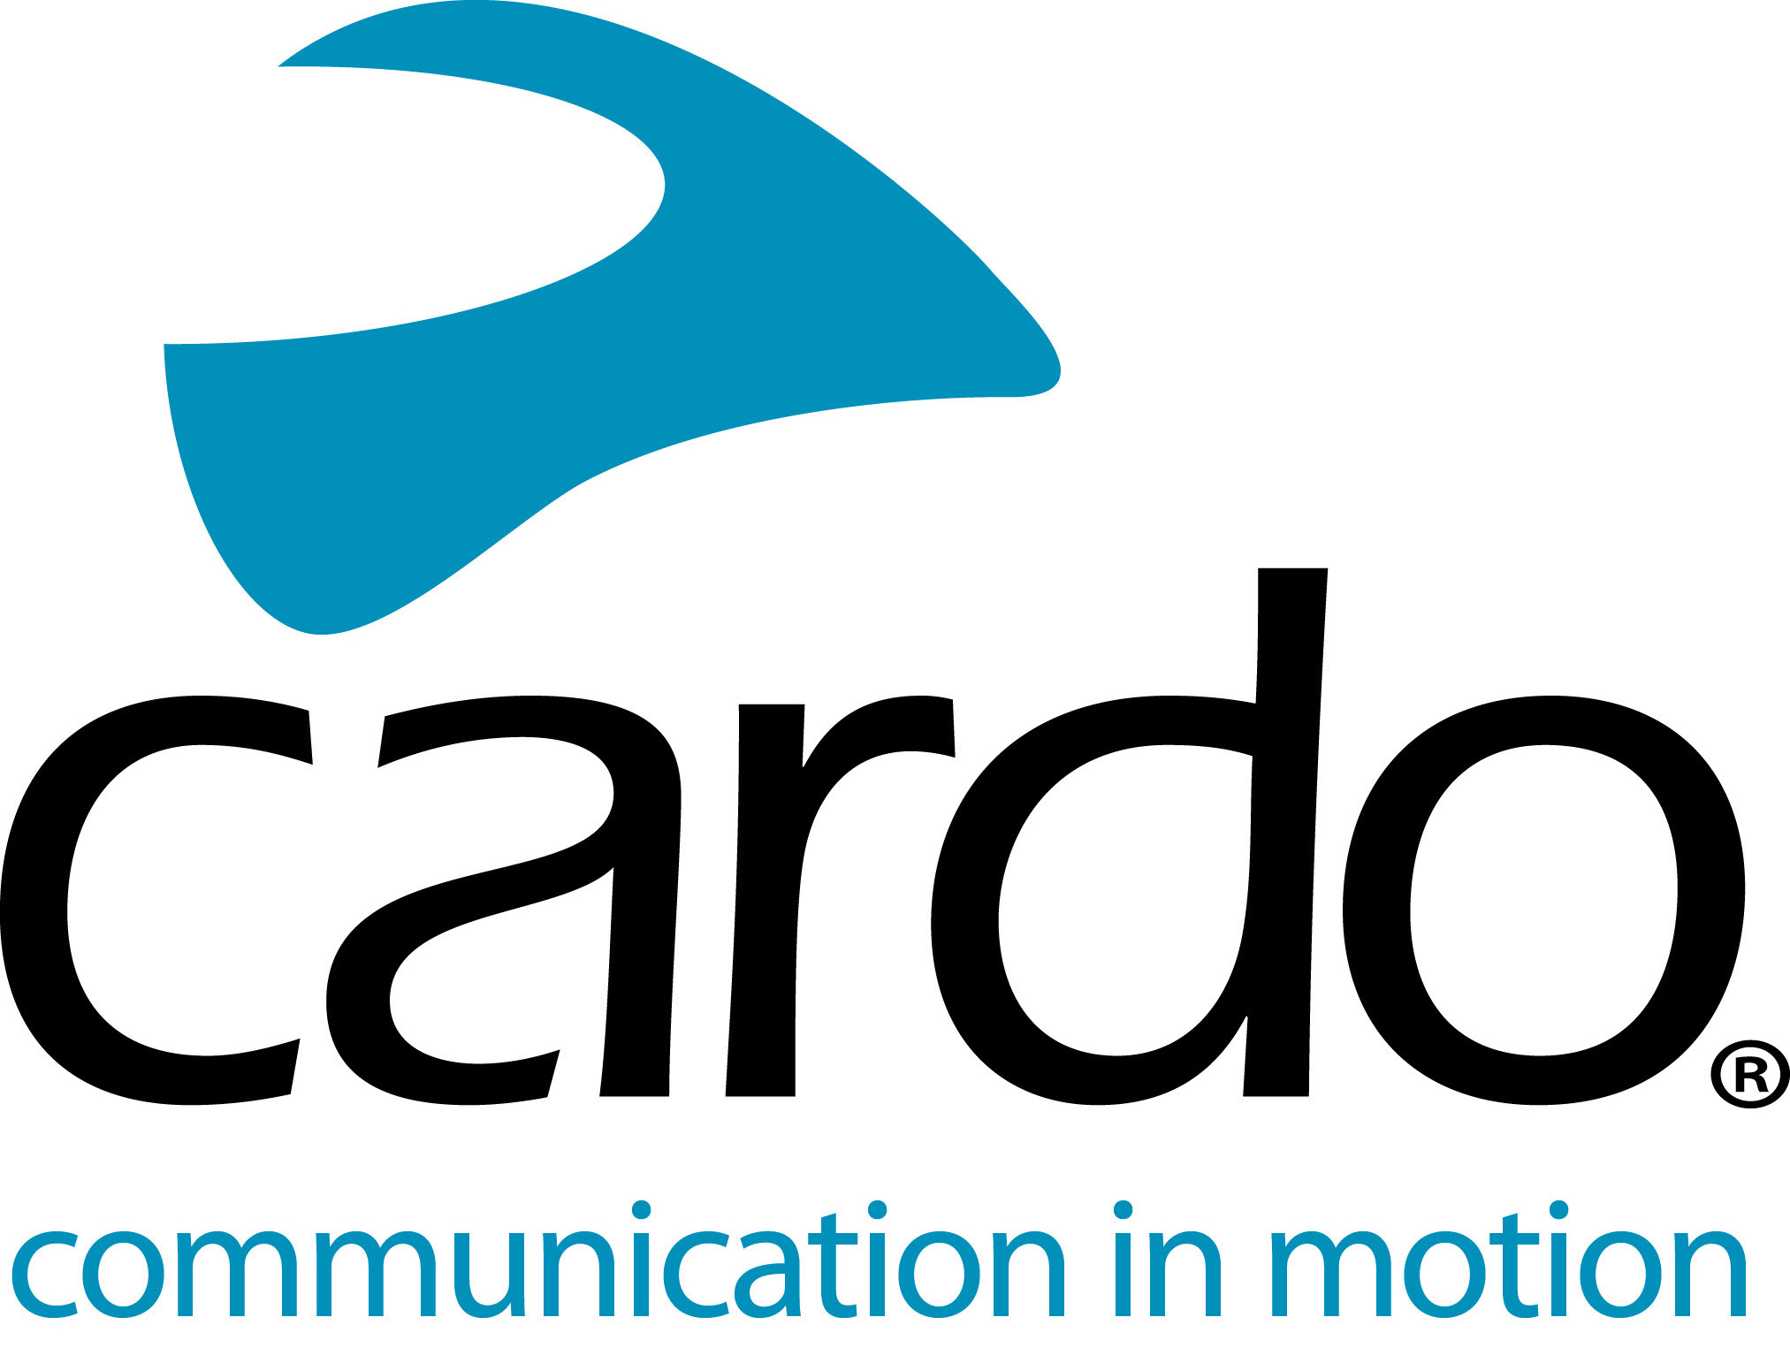
Supercross Riders and Their Teams Will Have the Opportunity to Communicate in Real Time During the Monster Energy Cup.
Plano, Texas (October 15, 2019) – Cardo Systems, Ltd., the global market leader in wireless communication systems for motorcyclists, today announced Supercross race teams will have the opportunity to utilise Cardo’s cutting-edge communication technology during the Monster Energy Cup on October 19. For the first time ever in professional Supercross, riders will be able to communicate instantly with their teams during the race, giving them the chance to make real-time adjustments in the midst of the competition. Already in use by a number of teams in their training, Cardo products have been tested and proven in the Supercross environment on tracks all around the world.
The Monster Energy Cup is one of the most exciting supercross exhibitions of the year. As a result of this deal, all teams competing in the event will have the opportunity to use Cardo’s top-of-the-line product, the PACKTALK BOLD. The PACKTALK BOLD is powered by Cardo’s industry-leading Dynamic Mesh Communication™ (DMC) technology, which allows teams to create an intercom group and stay seamlessly connected with 2 to 15 members of their team, including their riders, throughout the competition. Of course, the security of the team conversations is of the upmost importance, and with specific algorithms for device authentication and end-to-end encryption, the privacy of these individual networks is impenetrable by any outside listeners. The IP67 waterproof and dustproof design of the PACKTALK also provides durability and dependability regardless of track conditions. In addition, the Cardo PACKTALK BOLD features sound by JBL, so riders will experience crystal-clear sound quality when communicating throughout the race.
“The Monster Energy Cup is one of the most highly anticipated and exciting events of the year, and we couldn’t have asked for a better setting for Cardo Systems to make its debut on the Supercross circuit,” said Jamie Cheek, Cardo VP of Sales NA. “So many of these teams are already using our PACKTALK products in their training and the feedback we have received has been overwhelmingly positive. The introduction of our communication devices is going to allow them to navigate the competition unlike ever before with real-time communication, adding another layer of excitement to what is already an incredible event.”
The Monster Energy Cup is an exhibition race hosted by the AMA Supercross Championship on the final night of the racing season. The invite-only event encapsulates the excitement of an entire season into one night with many of the best racers from around the world competing for a $1 million prize, the largest prize in motorcycle racing. This year’s event takes place on Saturday, October 19, at Sam Boyd stadium in Las Vegas and will be broadcast live on FOX Sports and available to stream online. For more information on the event you can visit www.monstersupercrosslive.com.
For more information about Cardo Systems, please visit www.cardosystems.com. Also visit us and join the conversation on Facebook, Twitter and Instagram.
About Cardo
Cardo Systems specialises in the design, development, manufacturing and sale of state-of-the-art wireless communication and entertainment systems for motorcycle riders. Since inception in 2004, Cardo has pioneered the vast majority of innovations for Bluetooth motorcycle communication systems. The company’s products, now available in over 100 countries, are the world’s leading communication devices for the motorcycle industry.
For press enquiries:
press@cardosystems.media | www.cardosystems.com

