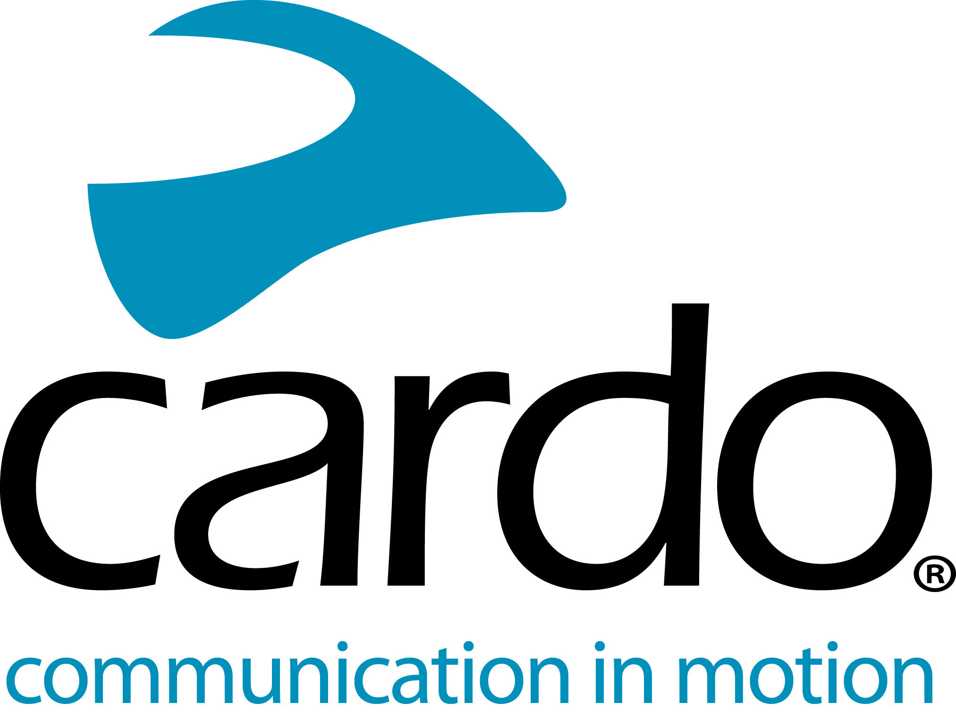

Cardo Systems - solving your Christmas present buying dilemma…
Those people looking for the perfect gift for the motorcyclist in their lives can relax as the Cardo Systems range offers a number of choices that any motorcyclist would be happy to unwrap!
For those riders who have already got a Cardo Systems unit, why not upgrade them to the ‘Ultimate Sound Experience’ with a JBL Audio Set. Priced at €89.95/£84.98, the Audio Set combines hardware engineered speakers with Sound by JBL and software to deliver an unmatched audio experience for motorcyclists.
Whether playing music, taking phone calls or communicating with other riders, treat your loved one to sound quality on another level. The 45mm speakers will also work with products from other motorcycle communication brands - provided they feature an amplifier that can drive speakers with 80Ω impedance.
Want to really treat your loved one this year? Why not give them the gift of ‘communication’ with one of the units from the Cardo Systems FREECOM+ or PACKTALK ranges.
Prices start at €139.95/£129.99 for a FREECOM1+ single unit, to €307.05/£349.98 for the special edition PACKTALK Black.
The FREECOM1+ packs a number of premium features for the price including Automatic Volume Control, and built-in FM radio as standard - unlike its competitors. The PACKTALK range boasts features including set-and-forget Dynamic Mesh Communication connectivity, Natural Voice Operation and comes with JBL speakers as standard.
The PACKTALK range features Dynamic Mesh connectivity keeping riders reliably connected to each other and their chosen devices with set-and-forget functionality and automatic reconnecting after being out of range with no manual input required. All PACKTALK units and the FREECOM4+ come as standard with JBL speakers for premium sound and feature Natural Voice Operation meaning common tasks can be done without riders needing to remove their hands from the handlebars.
All Cardo units are waterproof and fully supported future updates from Cardo and have 13-hours of battery life - as well as the option to charge on the go. The entire FREECOM+ and PACKTALK ranges can be controlled using Cardo’s free mobile app, Cardo Connect™.
Find the right Cardo Systems gift for the motorcyclist in your life - or why not just treat yourself?!
See the complete Cardo Systems line-up, visit www.cardosystems.com or contact your local distributor.
To join the conversation, follow along on the Cardo Systems Facebook, Twitter and Instagram channels or check out the YouTube channel.
About Cardo
Cardo Systems specialises in the design, development, manufacturing and sale of state-of-the-art wireless communication and entertainment systems for motorcycle riders. Since inception in 2004, Cardo has pioneered the vast majority of innovations for Bluetooth motorcycle communication systems. The company’s products, now available in over 100 countries, are the world’s leading communication devices for the motorcycle industry.
For press enquiries:
press@cardosystems.media | www.cardosystems.com

