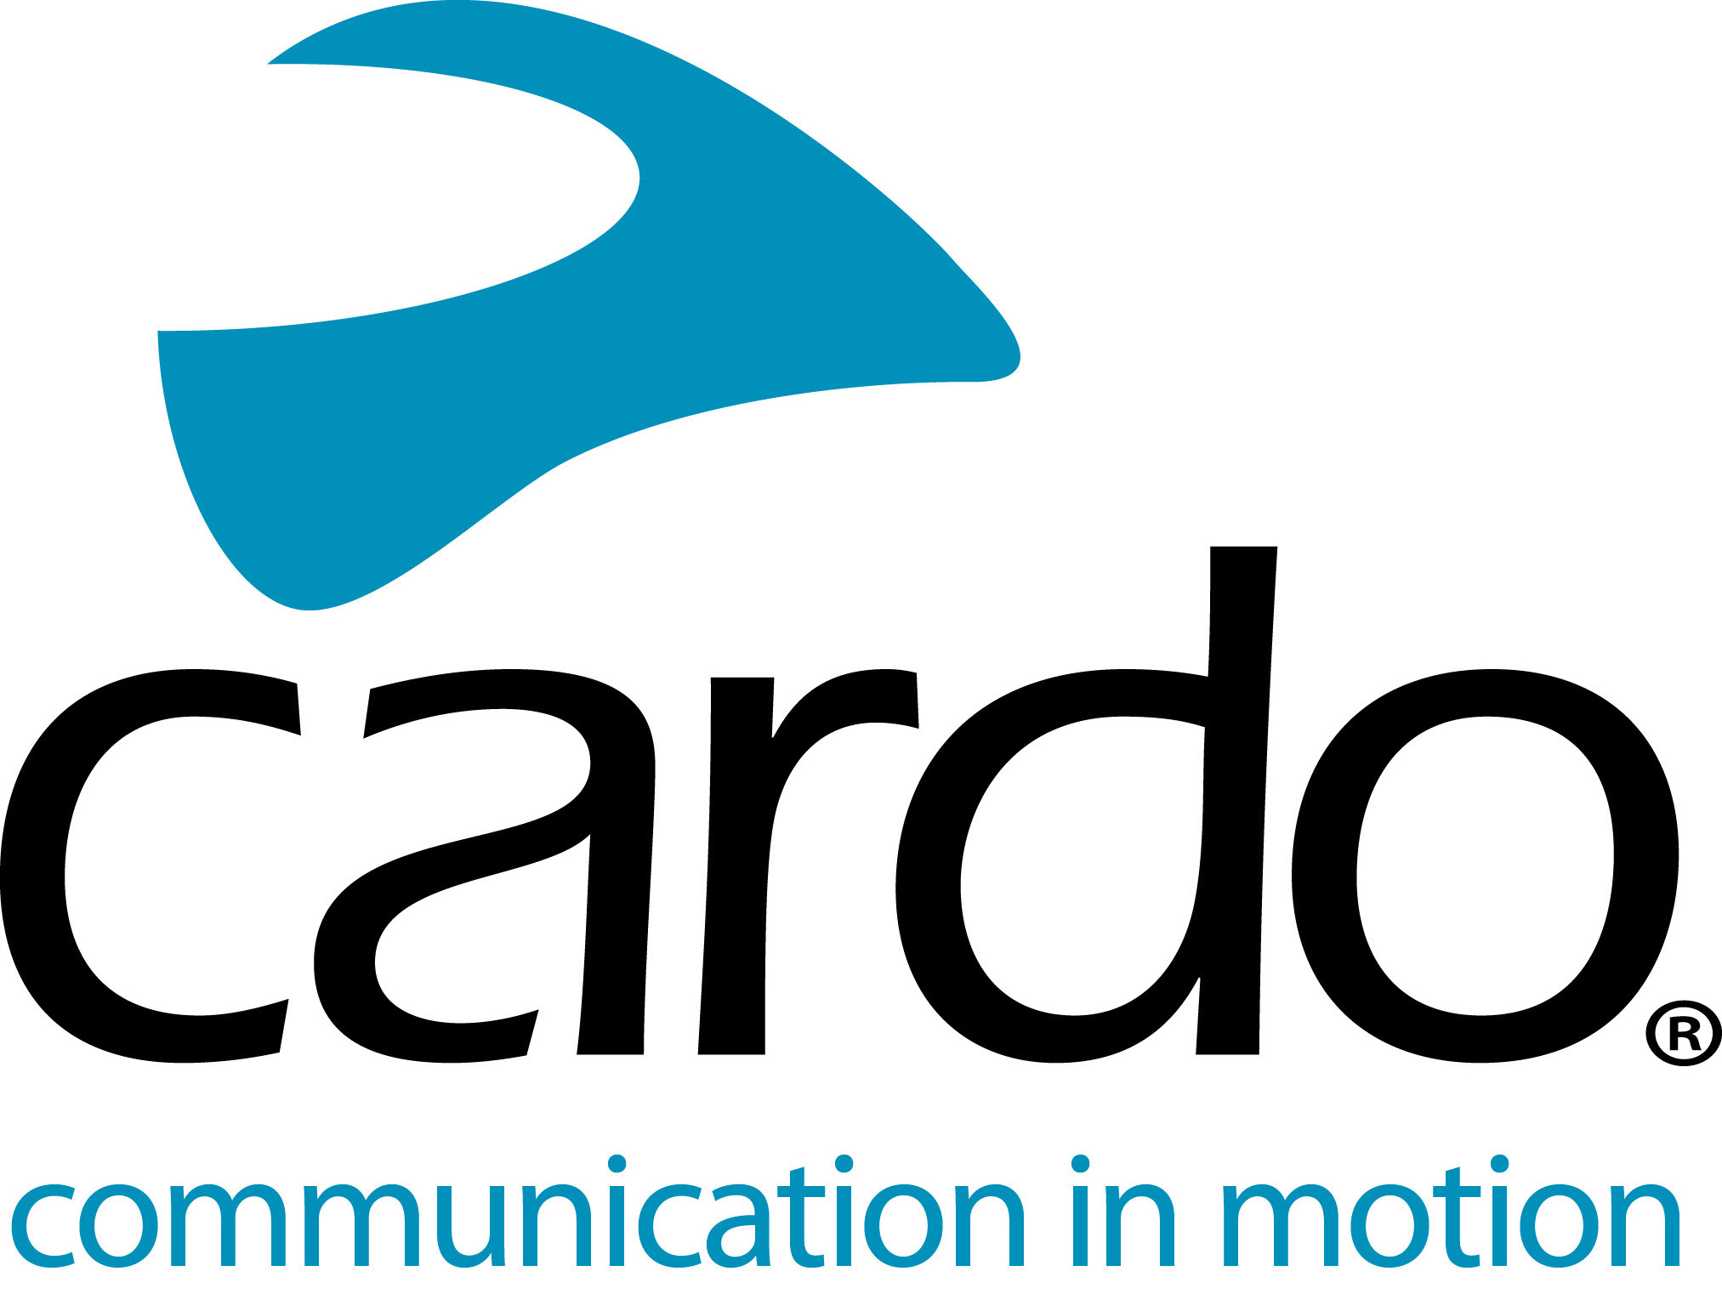

Cardo Systems signs multi-year agreement with Jetwerx Inc.
Cardo Systems signs a multi-year agreement with Jetwerx Inc. to be the exclusive communication partner of the Rockstar Energy Triple Crown Championship series for 2020 and beyond.
CEO Jetwerx Inc., Justin Thompson, said: "We are very excited to be making history with Cardo Systems and have broken the ice for their product PACKTALK BOLD powered by Dynamic Mesh Communication (DMC) to be fully legal and allowed with no restrictions in all Rockstar Energy Triple Crown competition events. We believe this is a great and safe way for riders and mechanics to have better communication and allow for safer racing."
Jetwerx and Cardo Systems will be working with factory and privateer teams educating them on the PACKTALK BOLD communication system and how it can be a great tool to take their racing programs to a new level of safety and efficiency. The PACKTALK BOLD system debuted at MEC Supercross in 2019, the innovative communication system was welcomed by riders and teams with great reviews.
Jamie Cheek, Cardo VP of Sales NA, said: "So many of these teams are already using our PACKTALK products in their training and the feedback we have received has been overwhelmingly positive. The introduction of our communication devices is going to allow them to navigate the competition unlike ever before with real-time communication, adding another layer of excitement to what is already an incredible event."
Join the conversation and the #CardoFam on Facebook, Twitter and Instagram.
About Cardo
Cardo Systems specialises in the design, development, manufacturing and sale of state-of-the-art wireless communication and entertainment systems for motorcycle riders. Since inception in 2004, Cardo has pioneered the vast majority of innovations for Bluetooth motorcycle communication systems. The company’s products, now available in over 100 countries, are the world’s leading communication devices for the motorcycle industry.

