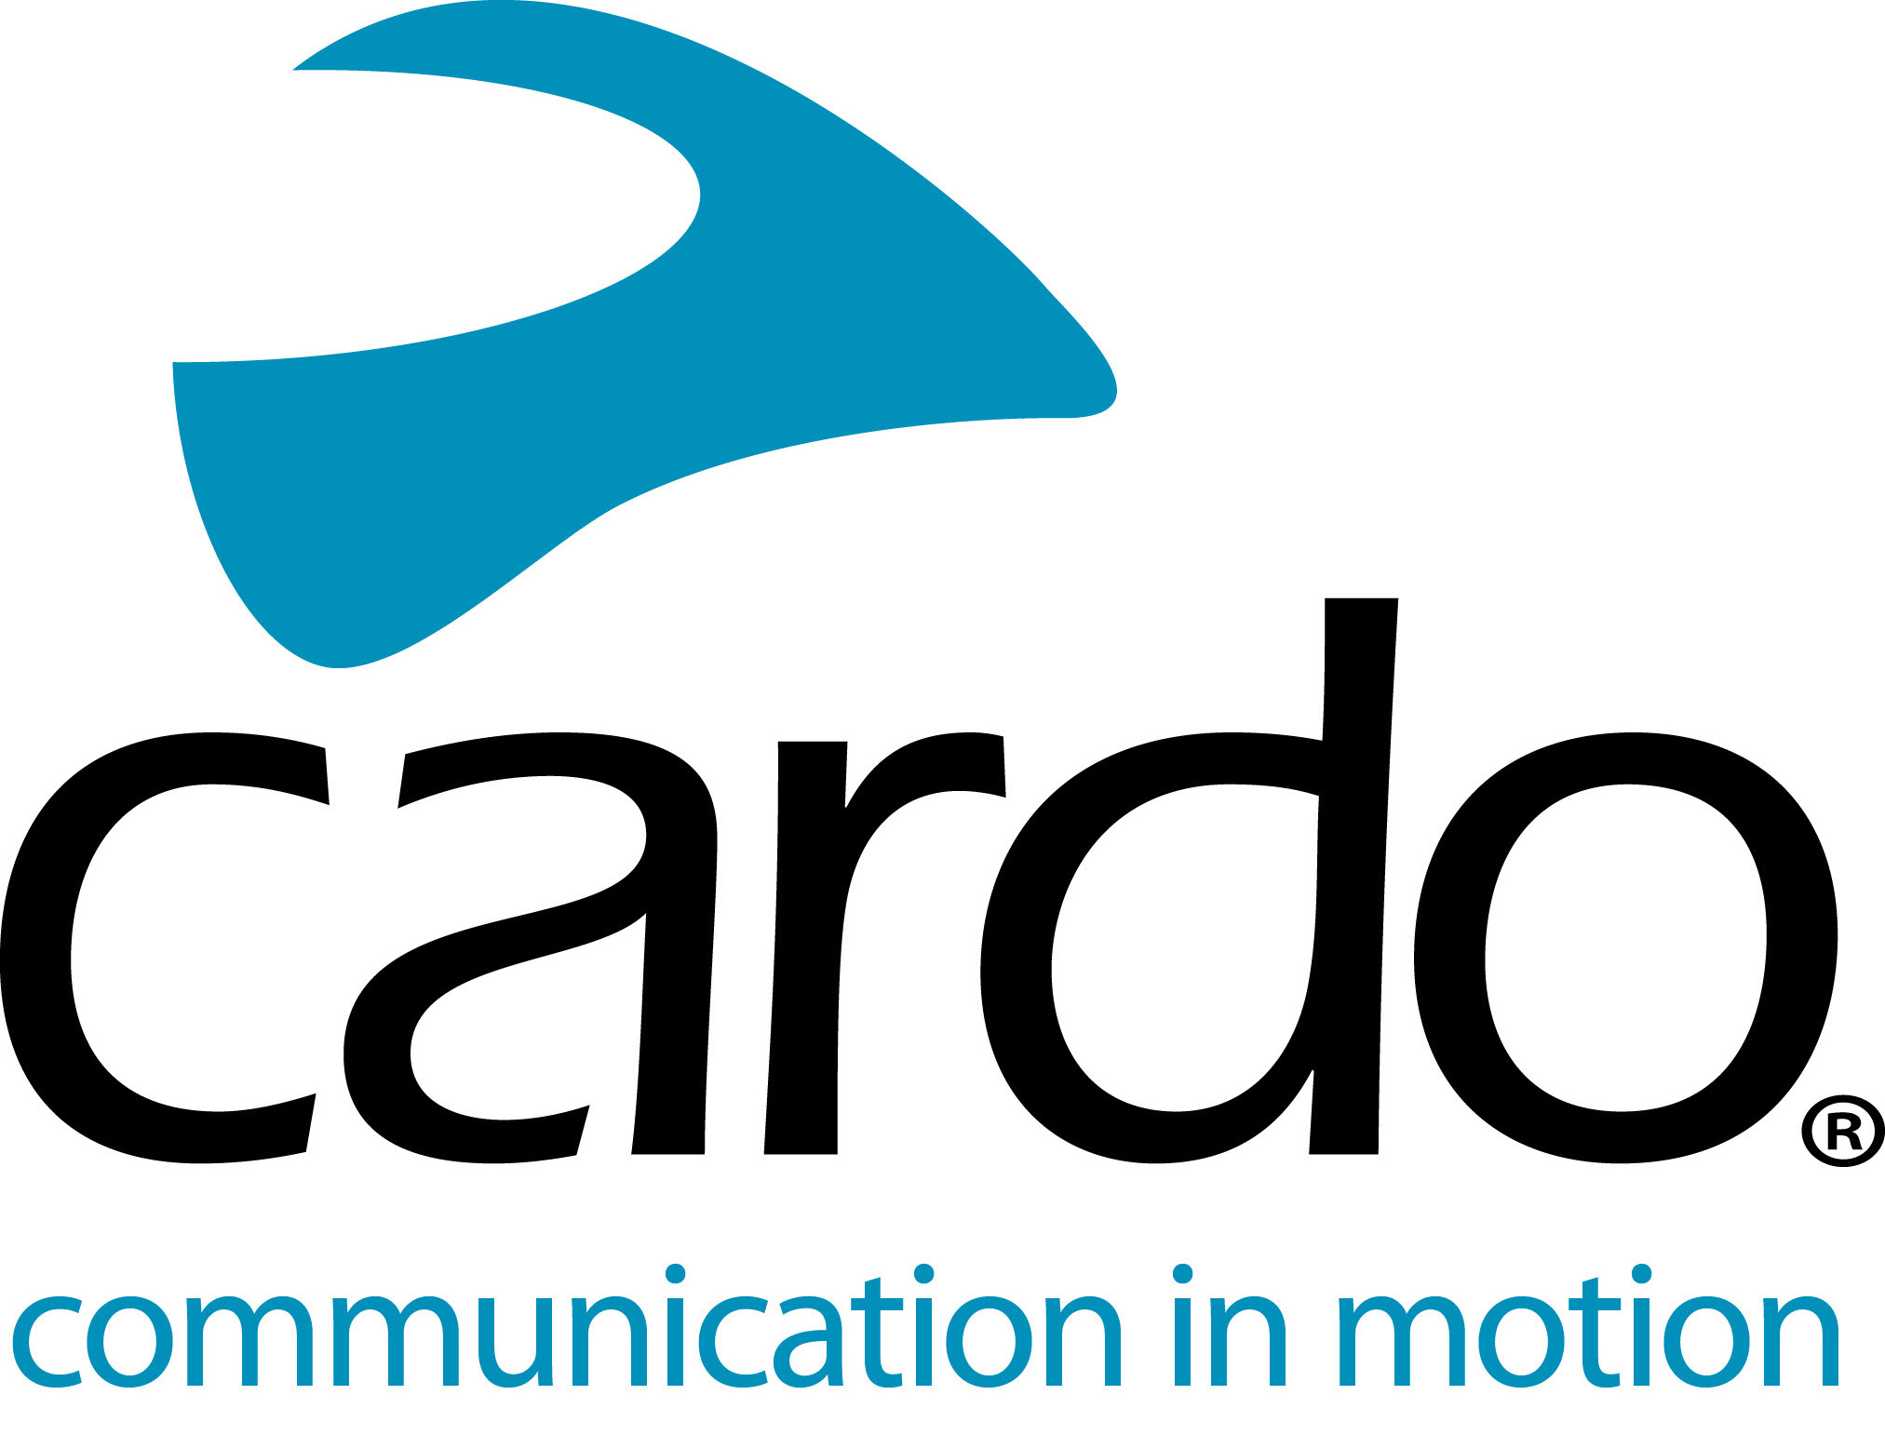

Cardo Systems proud to support Arunas Gelazninkas, ‘Original by Motul’ Dakar winner
Global market leader in wireless communication for motorcyclists, Cardo Systems, is proud to have supported the winner of the ‘Original by Motul’ class at the 2021 Dakar, working with Aruna Gelazninkas during his preparation and training for the iconic - and arduous - race.
It was the third time that Lithuanian rider Aruna Gelazninkas had taken part in the Dakar, making his debut in Peru in 2019 and finishing 24th in the bike category. He has made history by becoming the first Lithuanian rider to complete ‘malles-moto’ - the previous name for ‘Original by Motul class.
“I didn’t really have an objective in terms of position going into the Dakar this year, there were some great riders in the ‘Original by Motul’ category so for me I thought if I could make it into the top three of the category, I would be happy.
“I trained very hard this year and the Cardo System devices played an important role. Getting feedback in real-time and the ability to speak with other riders while riding was great. Training in the Dubai desert, there are a lot of dangers and potential for things to go wrong, so to be able to communicate is great as the lead rider can say where we should go - and we can joke around too. It was great to be able to communicate with my team members - they can say if I need to push, be calm or give it full gas.”
The ease-of-use of the PACKTALK Bold devices made them a vital piece of kit for Gelazninkas. Features such as the 13-hour battery life, Dynamic Mesh Communication (DMC) connection and 1600m (1 mile) range also helped ensure the Cardo Systems device was the right tool for the job. The dust and waterproof shell meant that Gelazninkas didn’t need to worry about them getting dirty or damaged easily, handy when training for a race which takes place in 14 stages across 15 days, covering nearly 9000 kilometres through desert, wasteland and rocky areas.
“When you’re training, you don’t have a lot of time to mess around with things and try to get them to work as you want to spend as much time as you can practicing and improving. The fact that the system just worked made it simple and easy. The JBL speakers are amazing, the sound is great. It is a really good and useful thing in my sporting life.”
As well as being a multiple Lithuanian off-road riding Champion and winning the Tuareg Rally in 2019, when he’s not competing, Gelazninkas works as a motorcycle instructor at his #AGDAKARSCHOOL - where he teaches students enduro, motocross and rally - is another application where he has found the Cardo System PACKTALK Bold devices useful.
“I used to have to stop my students all the time to give them feedback or put it on a pitboard and hope that they see it, but now I can do that straight away and they can apply my comments and suggestions immediately. In this sport, instant feedback is very important as you can’t remember your body movements after five minutes. It’s 100% more effective with Cardo - I can’t imagine my school without Cardo units now, they’ve made my training a lot more professional. A lot of my students and colleagues have gone on to buy a Cardo device for themselves after using it at the school, which shows how useful they found them!”
Find out more about the Cardo Systems PACKTALK Bold on the Cardo Systems website - www.cardosystems.com or visit your local Cardo Systems stockist.
To join the conversation, follow along on the Cardo Systems Facebook, Twitter and Instagram channels or check out the YouTube channel.
Photo credit: #ZigmasDakarteam
About Cardo
Cardo Systems specialises in the design, development, manufacturing and sale of state-of-the-art wireless communication and entertainment systems for motorcycle riders. Since inception in 2004, Cardo has pioneered the vast majority of innovations for Bluetooth motorcycle communication systems. The company’s products, now available in over 100 countries, are the world’s leading communication devices for the motorcycle industry.
Notes to editors
The ‘Original by Motul’ category refers to bike and quad competitors competing without any kind of assistance. Instead, riders and drivers rely on the Dakar organisers to transport their limited list of permitted belongings and are able to personally use generators, compressors and toolboxes belonging to the organisation.

