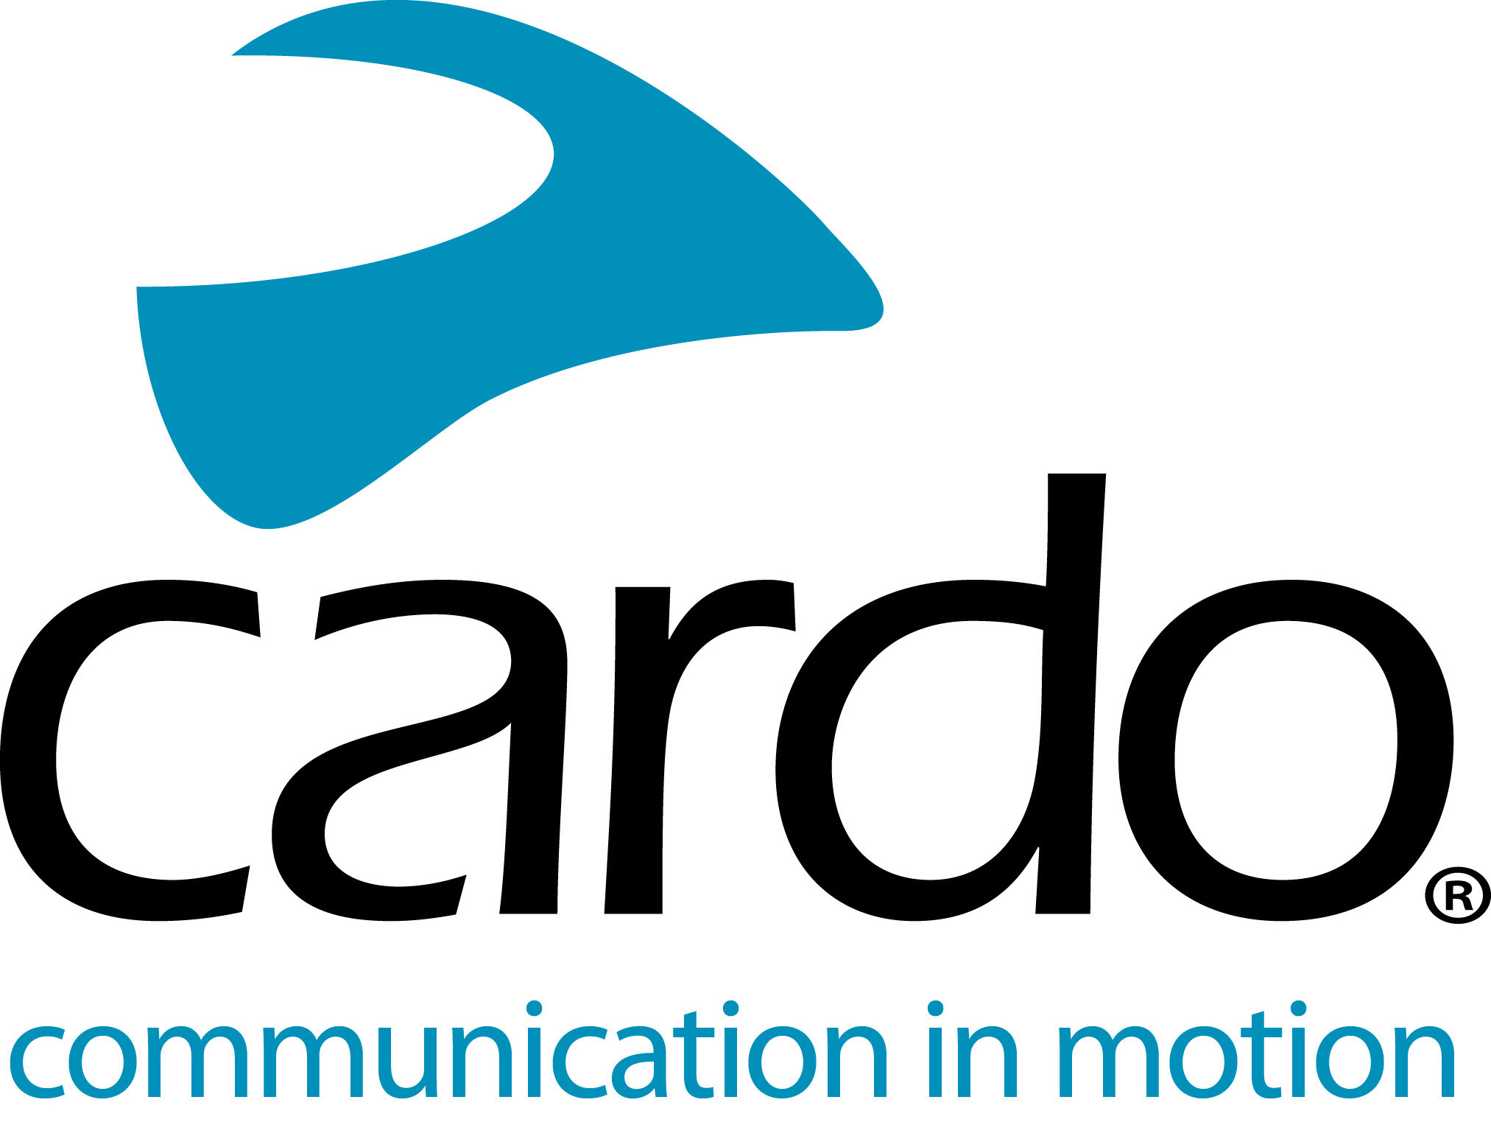

Cardo Systems partners with MotoAmerica and Jetwerx in the USA
Global leader in wireless motorcycle communication units, Cardo Systems, is proud to announce its 2020 season series sponsorship of MotoAmerica and its multi-year agreement with Jetwerx Inc as exclusive communication partner of the Rockstar Energy Triple Crown Championship series.
Read the full story for each on the Cardo Systems Media Site:
Cardo Systems becomes MotoAmerica series sponsor for the 2020 season
Cardo Systems signs multi-year agreement with Jetwerx Inc.
For more information on the Cardo Systems range, please visit, www.cardosystems.com.
Join the conversation on Facebook, Twitter and Instagram.
About Cardo
Cardo Systems specialises in the design, development, manufacturing and sale of state-of-the-art wireless communication and entertainment systems for motorcycle riders. Since inception in 2004, Cardo has pioneered the vast majority of innovations for Bluetooth motorcycle communication systems. The company’s products, now available in over 100 countries, are the world’s leading communication devices for the motorcycle industry.

