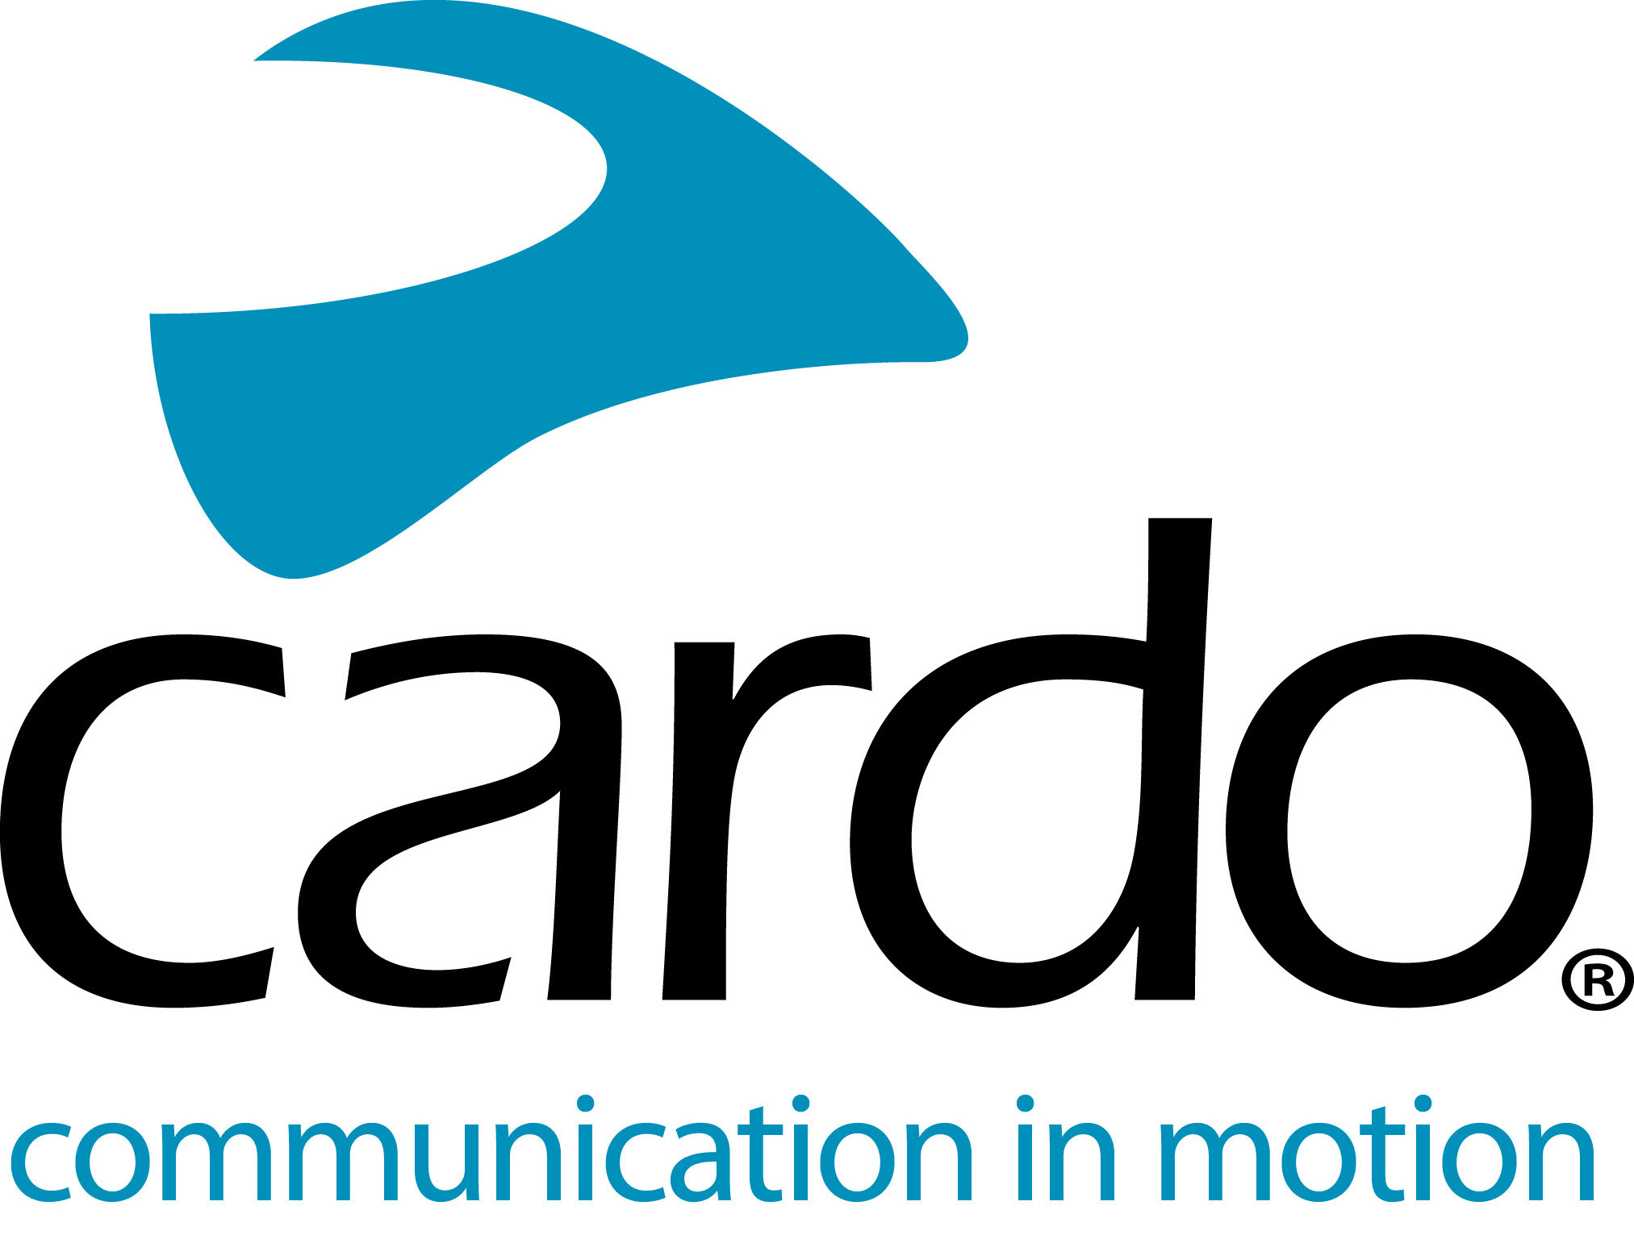

Cardo Systems PACKTALK helping Buffos School promote road safety
Since opening in 2007, Buffos School in Spain has trained over 5000 students and have firmly established themselves as the country’s leading school for Road Safety and saving lives, a task contributed by the school's use of Cardo Systems PACKTALK Bold units.
Working with groups of five riders at a time, the instructors will follow behind the group to assess their strengths and potential areas for improvement, giving feedback in real-time. Manager of Buffos Safe Riding School - and racer in the Spanish Championship of Speed - Miguel Duran explains what he was looking for in a communications unit:
“To be able to give directions to the riders while we were riding, I needed a device that allowed communication without worrying about the connection and Packtalk Bold offered everything I needed. The DMC connectivity, battery life and sound quality are my top three favourite features. The ability for the connection to automatically reconnect when swapping places with other riders or moving in and out of range without touching it is the best thing.
“We tried the units originally because of a recommendation from my friends - and ex-students - at the Guardia Civil as they use them on their private bikes. As soon as I had tried them out, I saw that it was a very powerful tool and we started to use them in our lessons straight away. I wouldn’t ride without one now, for me, it is part of the equipment that I recommend to my students. Just like arming yourself with the right skills through the riding courses, the unit is a tool to help defend ourselves on the road.”
But, in Miguel’s opinion, how does it make riding safer for those using it?
“For us, road safety is the most important thing and the PACKTALK Bold helps enormously with that. You can receive and give vocal instructions without having to take your eyes off the road or your hands off the handlebars - such as speaking with other members of the group or listening to instructions from the GPS. As you ride around, you encounter many things - oil, animals and road accidents to name just a few. When riding with a communications unit, the first one to see it can communicate it, giving everyone longer to prepare and react in advance.
“I'll give you an example that happened to me a few days ago. I talked to a friend who fell off his bike and without having to take the phone out of his jacket, he was able to call for assistance. This is saving lives! If you're in a group connected to DMC [Dynamic Mesh Communication] technology, you can share with everyone what you see on the road by warning of hazards or preventing accidents. To wear a PACKTALK or not to wear it makes a difference. I would even use it on a closed circuit with our team and mechanics to see and fix things.”
With many of their 400 annual students coming from large companies, the riding school works closely with Public Administrations to help spread the message of road safety, how to save lives and ultimately to enjoy the freedom of two-wheels even more.
Find more information about Cardo Systems and the complete product line-up at www.cardosystems.com.
Join the conversation on Facebook, Twitter and Instagram and see all the latest videos on YouTube.
About Cardo
Cardo Systems specialises in the design, development, manufacturing and sale of state-of-the-art wireless communication and entertainment systems for motorcycle riders. Since inception in 2004, Cardo has pioneered the vast majority of innovations for Bluetooth motorcycle communication systems. The company’s products, now available in over 100 countries, are the world’s leading communication devices for the motorcycle industry.

