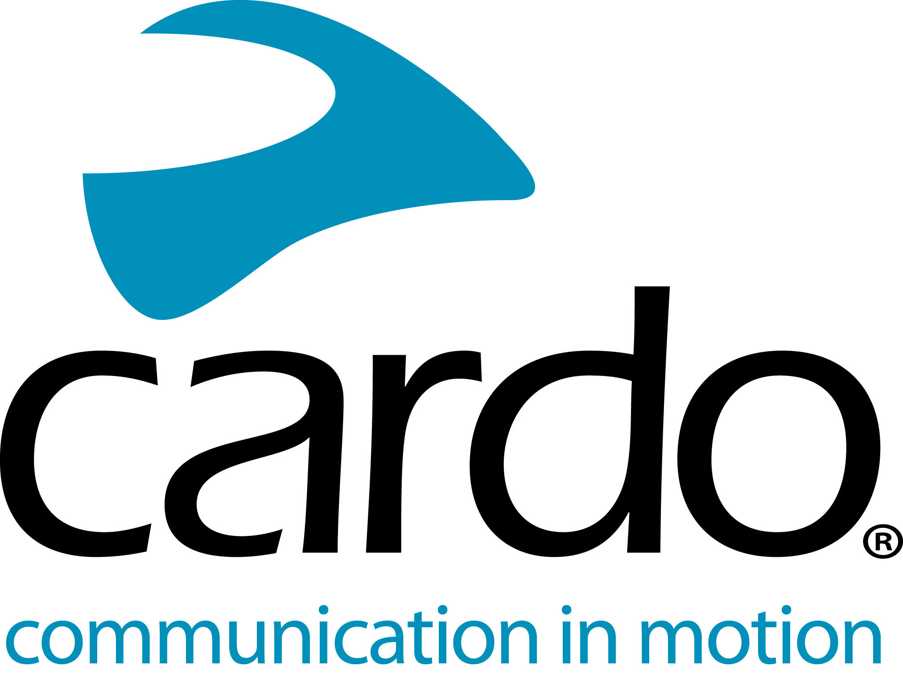

Cardo Systems PACKTALK Bold - lifesaving communicators
Cardo Systems, is proud to be the communicator of choice by emergency service providers across the world. From the police forces in France, UK and South Africa, to United Hatzalah in Jerusalem, Israel and even the Singapore Armed Forces Parachute Team…
The global market leader in wireless communication systems for motorcyclists, Cardo Systems, is proud to be the communicator of choice by emergency service providers across the world. From the police forces in France, UK and South Africa, to United Hatzalah in Jerusalem, Israel and even the Singapore Armed Forces Parachute Team…
When operating as an emergency service, it’s paramount to trust the equipment being used; receiving and giving messages can often mean the difference between life and death.
What makes the Cardo System PACKTALK Bold a great solution for the task?
‘Set-and-forget’ Dynamic Mesh Communication connectivity means that once the PACKTALK Bold units are paired, they’re paired for life - there’s no fiddling around at the beginning or end of a shift trying to get them all to pair making the experience smooth with the confidence it's reliable. The automatic reconnection of the units also saves time while out on the road when the riders move in and out of the 1600-metre (one mile) range offered by the PACKTALK Bold regularly. There’s also the potential to connect to 2-15 riders, which comes in extremely handy when riding in large groups.
Incorrectly heard information can make a big difference. The PACKTALK Bold comes with JBL speakers as standard, offering users the ‘Ultimate Sound Experience’ and meaning voice communications can be heard with extreme clarity - the result of a strategic partnership between world leading experts, Cardo Systems and JBL, setting a new standard for audio quality for helmet communication systems. The Automatic volume control adjusts the sound volume based on the outside ambient noise too, so users can be sure they don’t miss a critical communication due to the noise of an engine, sirens or wind.
When free-falling through the air, it’s not always possible to press buttons - just like when riding a police or ambulance motorcycle - that’s where the Natural Voice Operation comes in. Riders can simply say ‘Hey Cardo’ and the device reacts instantly to follow the given command, without the rider having to press any buttons. The technology seamlessly integrates with Apple’s Siri™ and “OK Google”™ voice-command platforms too.
The 13 hours of battery life and the ability to charge on the go ensures that users are always connected and don’t have to worry about running out of battery when moving in to make that important arrest.
The PACKTALK Bold is water and dustproof enabling it to be used in all weather conditions with confidence.
VP Global Sales at Cardo Systems, Jonathan Yanai comments: “We’re extremely proud to be the communicator of choice for such uses. We pride ourselves on helping people carry out their jobs as effectively as possible and aim to make use of the unit as seamless as possible for them.
“The units used by selected police riders of France, South Africa and the UK and the Red Lions parachute team over in Singapore is the same as what we sell to customers, which you have to admit is pretty cool! Being used in such challenging conditions, we learn a lot through feedback from these users about innovations and improvements too, which are ultimately put into products for customers.”
There has been a 37% reduction in accidents since the Israeli police started using the Cardo units 10 years ago. Its two-wheeled fleet contains 1450 vehicles in total - 350 motorcycles and 1100 scooters. When asked about the effectiveness of the units, Yaron Ben Yossef, Senior Staff Sergeant Major, Head of Motorcycles Section, Terrorism and Riot Control Sector and Emergency Department in Israel simply says: “This system saves lives.”
For more information on the PACKTALK Bold or to find out more about the whole Cardo Systems range, visit: www.cardosystems.com
You can find more information about Cardo Systems at www.cardosystems.com.
Join the conversation on Facebook, Twitter and Instagram.
About Cardo
Cardo Systems specialises in the design, development, manufacturing and sale of state-of-the-art wireless communication and entertainment systems for motorcycle riders. Since inception in 2004, Cardo has pioneered the vast majority of innovations for Bluetooth motorcycle communication systems. The company’s products, now available in over 100 countries, are the world’s leading communication devices for the motorcycle industry.
For press enquiries:
For more information and for high-resolution images please contact press@cardosystems.media | www.cardosystems.com

