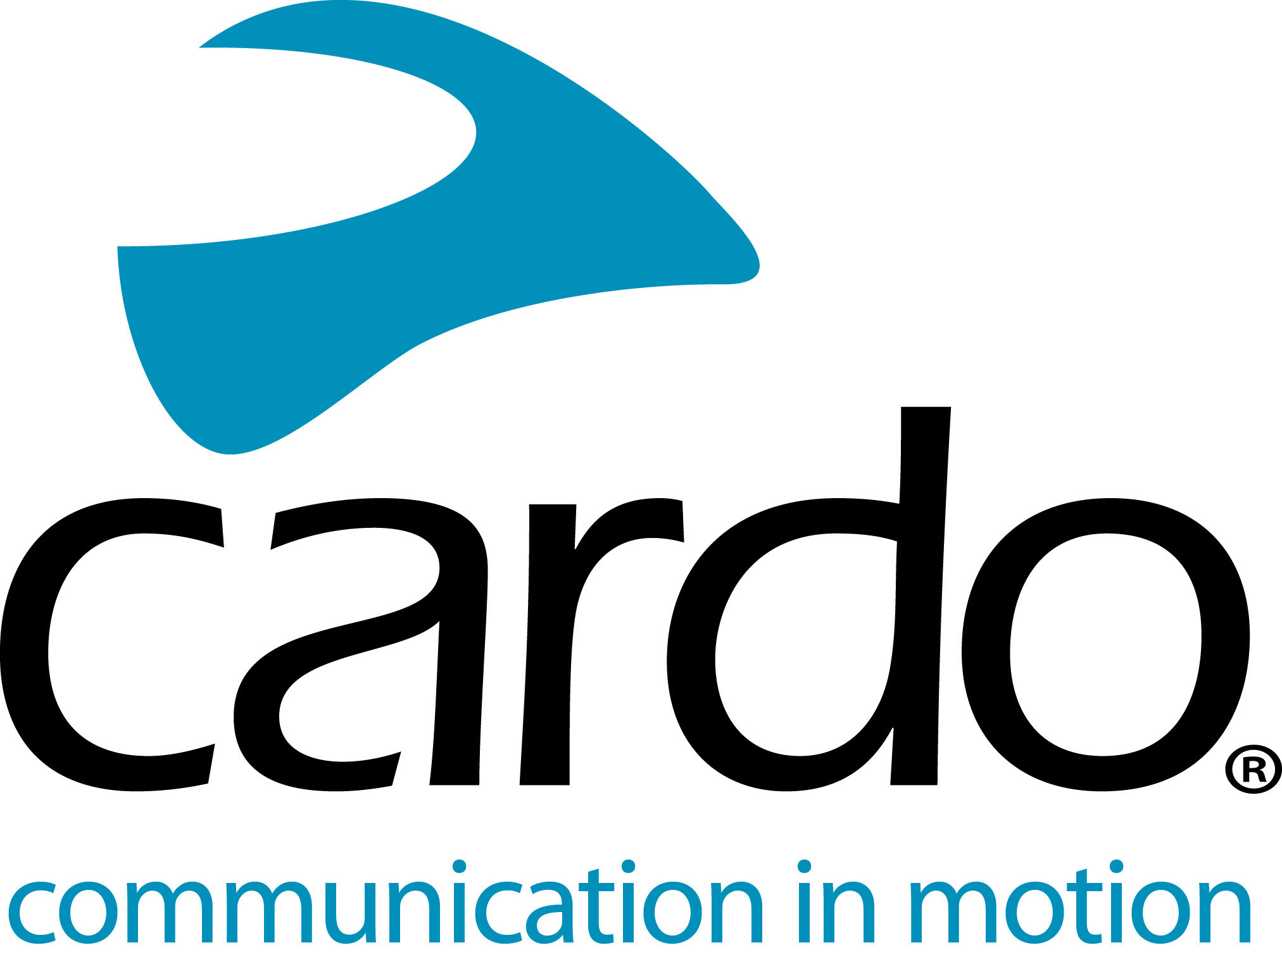
Cardo Systems now available at even more Hertz Ride locations
Cardo Systems, Ltd., the global market leader in wireless communication systems for motorcyclists, and Hertz Ride, expert in motorcycle rentals and tours, today announced the expansion of the rental availability of Cardo communication systems at select locations – adding two new locations in the U.S.
Motorcyclists renting from Hertz Ride now have the opportunity for a greater connection to their riding group, mobile device, GPS and music. This announcement is the result of an ongoing partnership, announced last year, which made Cardo the official communication system of Hertz Ride.
Hertz Ride service will now provide even more of their customers with the option to add Cardo’s PACKTALK BOLD or PACKTALK SLIM units to their two-wheeled vehicle rentals.
The partnership between Cardo Systems and Hertz Ride, was launched in June of 2018 and initially saw Cardo units in select locations around Europe. Debuting in Spain, France, Portugal and Italy to great success, the program has continued to expand to Austria and Slovenia, with select U.S. Hertz Ride locations now making Cardo’s PACKTALK lineup available. Going forward, Cardo and Hertz will look to continue expanding to Hertz Ride locations.
The PACKTALK products are powered by Cardo’s industry-leading Dynamic Mesh Communication™ (DMC) technology, which allow riders to remain seamlessly connected with up to 15 riders for an enhanced group riding experience. With Cardo’s natural voice-command, activating the device no longer requires a specific action such as push-to-talk, so riders can keep their hands on the bars at all times. Riders can simply say, “Hey Cardo” with the desired action to the always-on system and it reacts instantaneously. Plus, riders will experience sound by JBL, which delivers a superior audio experience to motorcyclists and sets a new standard in audio quality for helmet communications systems.
“For many people, especially renters, riding a motorcycle is all about the experience. With the addition of our industry-leading PACKTALK lineup to Hertz’s offering, we will be able to enhance that experience for these riders,” said Jonathan Yanai, Cardo’s VP Global Sales. “We are excited to continue our work with Hertz by not only offering this opportunity to U.S. riders, but to continue to expand our partnership to provide world-class experiences around the globe.”
To view a list of Hertz Ride locations offering Cardo’s PACKTALK lineup, visit hertzride.com.
For more information about Cardo Systems, please visit www.pama.com/cardo.
Join the conversation on Facebook, Twitter and Instagram.
About Cardo
Cardo Systems specialises in the design, development, manufacturing and sale of state-of-the-art wireless communication and entertainment systems for motorcycle riders. Since inception in 2004, Cardo has pioneered the vast majority of innovations for Bluetooth motorcycle communication systems. The company’s products, now available in over 100 countries, are the world’s leading communication devices for the motorcycle industry.
For press enquiries:
For more information on the Cardo Systems line of products and for high-resolution images please contact press@cardosystems.media | www.pama.com/cardo

