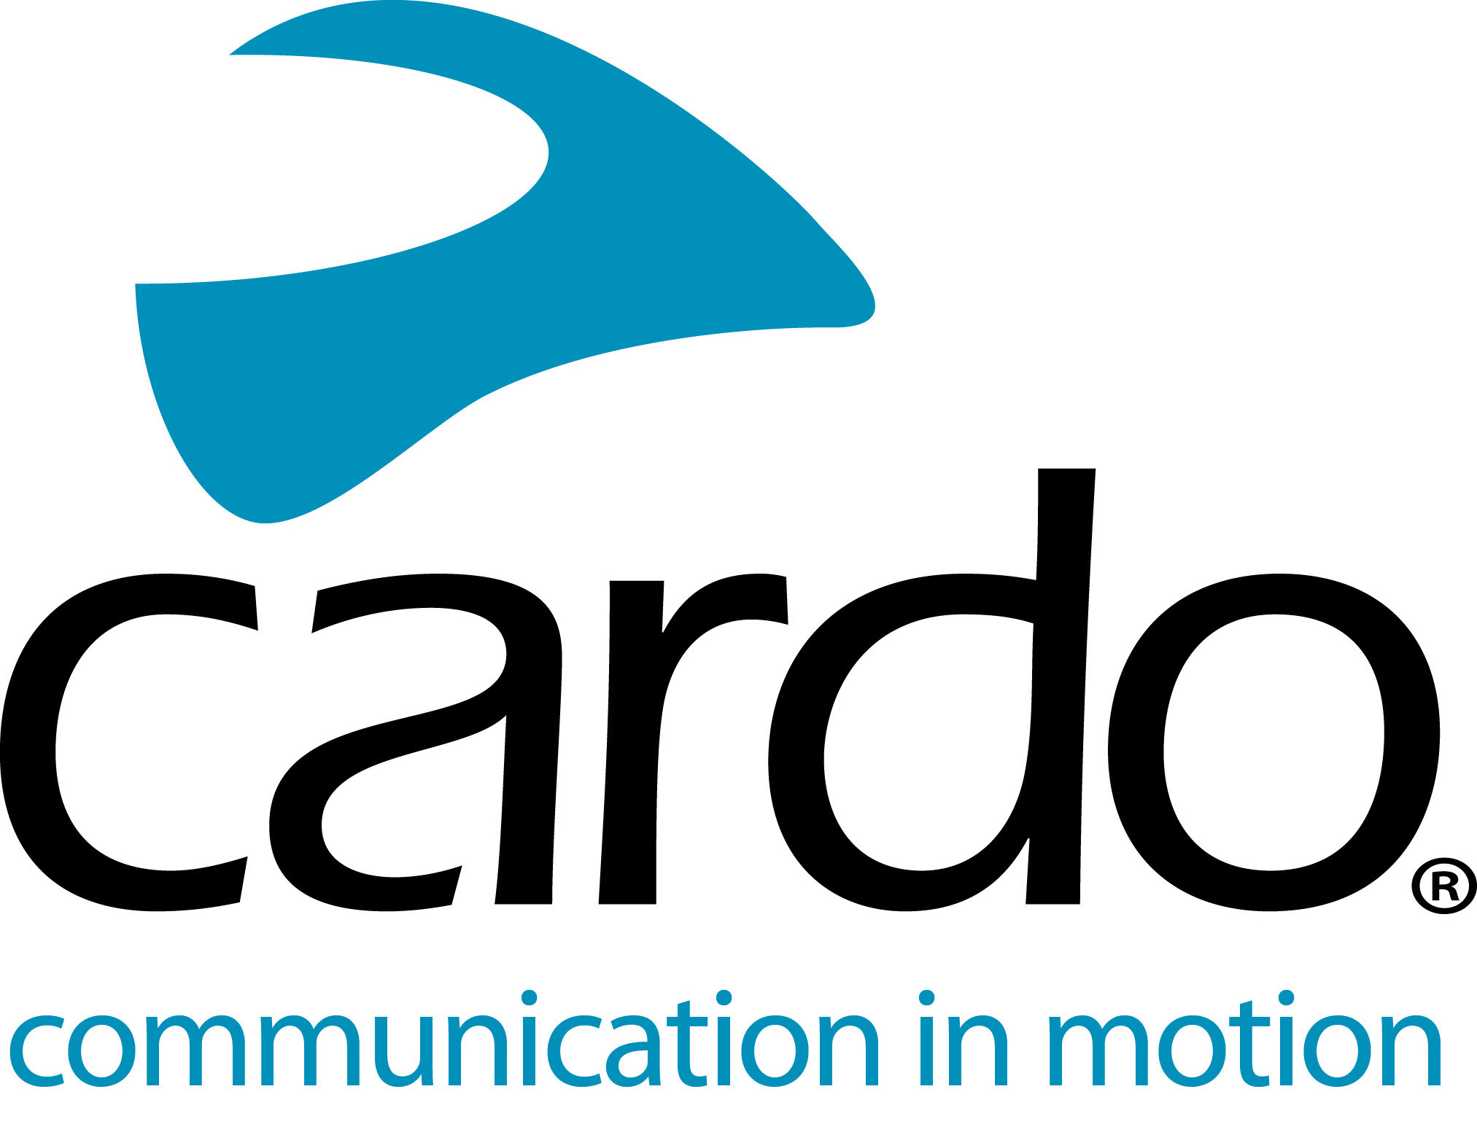

CARDO SYSTEMS’ NEW ‘AUDIO SET’ WITH SOUND BY JBL DELIVERS THE ULTIMATE

AUDIO EXPERIENCE FOR MOTORCYCLE RIDERS

Available for Preorder Now, Cardo’s All-New Accessory Kit Features 45mm Speakers and tuning from JBL, Compatible with PACKTALK, Freecom & Other Communication Devices*

Cardo Systems, the global market leader in wireless communication systems for motorcyclists, and JBL, a leading audio brand from HARMAN, today announced preorder availability of the all-new 45mm Audio Set – an accessory kit combining hardware engineered speaker with Sound by JBL and software to deliver an unmatched audio experience for motorcyclists. Whether playing music, taking phone calls, or communicating with other riders, the new accessory kit takes sound quality to another level.

“Audio quality is paramount to delivering an unmatched rider communication and entertainment experience, and with JBL’s state-of-art audio technology, we are delivering exactly that,” said Dan Emodi, Cardo Systems VP Marketing. “The Audio Kit accessory is a powerful tool that brings these incredible audio enhancements to a much wider range of our existing customers, as well as riders currently using other rider communication devices*.”

The Audio Set features a pair of 45 mm speakers with a narrow 42mm base to fit most modern helmets. The larger speakers provide deeper bass and a rounder, more natural overall sound than anything available on the market today. The speakers are equipped with a standard 3.5 mm jack and can be used with Cardo’s full range of legacy products, as well as products from other motorcycle communication brands – provided they feature an amplifier that can drive speakers with 80Ω impedance.

However, for PACKTALK and Freecom owners Cardo’s 45mm Audio Set offers far more than just a pair of speakers. At the heart of the accessory kit is JBL’s cutting-edge sound processing and equalizer technology, available through a simple software download via the Cardo Connect mobile app. The software enables superior sound quality and clarity, along with deeper bass and higher pitch.

JBL Sound Processing provides unmatched audio quality for music and voice alike, calibrating the audio output to be optimized for the 45 mm speakers. The sound processing is compatible with Cardo’s entire PACKTALK series, including SMARTPACK and SMARTH, and across the entire Freecom product line.

Additionally, PACKTALK owners will also be able to enjoy JBL Equalizer Sound Profiles that allow the rider to choose the audio configuration that best suits their preference or specific use case.
-MORE-

Three sound profiles are offered, including:
- Standard – Optimized for best overall sound
- Bass Boost – For optimal low-end tone
- Vocal – Optimal for phone calls and voice communication

The JBL Equalizer Sound Profiles are compatible with PACKTALK Bold and Slim, as well as SMARTPACK and SMARTH products.

Although the Audio Set’s full capabilities are only compatible with Cardo products, the JBL 45mm speakers can be utilized for an enhanced audio experience with any other motorcycle communication system that accommodate a standard 3.5mm jack and which feature an amplifier that can drive speakers with 80Ω impedance.

The Cardo-JBL partnership delivers the ultimate listening experience for all motorcyclists – whether riding through a mountain pass or commuting through city streets. In addition to the Audio Set, the two brands recently collaborated to make JBL speakers standard in Cardo’s 2019 PACKTALK lineup.

The Audio Set is available now for preorder on Cardo’s website, with units set to begin shipping April 2019.

For more information, visit Cardo Systems at www.cardosystems.com and join the conversation on Facebook, Twitter and Instagram.

About Cardo
Cardo Systems specializes in the design, development, manufacturing and sale of state-of-the-art communication and entertainment systems for motorcycle helmets. Since inception in 2004, Cardo has pioneered the vast majority of innovations for Bluetooth motorcycle communication systems. The company’s products, now available in over 85 countries, are the world’s leading communication devices for the motorcycle industry.

About JBL
JBL creates the amazing sound that shapes life’s most epic moments. From iconic events like Woodstock and concerts at Madison Square Garden, to games at Yankee Stadium and weekend road trips, JBL elevates listeners’ experiences with award-winning audio that lets them make the most of every moment. With unmatched professional credentials and over 70 years of delivering industry leading innovation, JBL is the authority in engineering superior sound.

For press enquiries:
For more information on the PACKTALK line of products and for high resolution images please contact press@cardosystems.media | www.cardosystems.com
*with a 3.5mm jack and a communicator that can drive speakers with 80Ω impedance.

