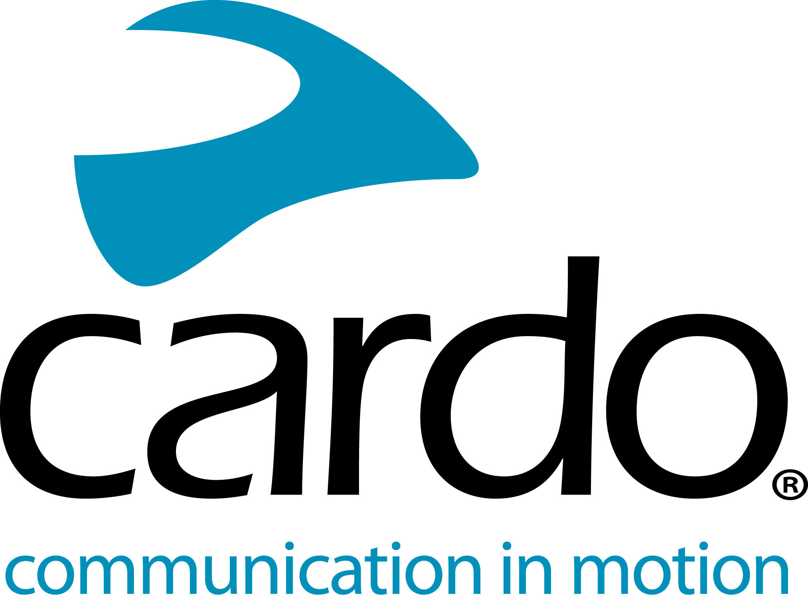
Cardo Systems launch special-edition PACKTALK BLACK
- New special-edition model joins industry-leading, DMC-powered PACKTALK lineup.
- The first motorcycle communicator featuring 45mm JBL Speakers as standard.
Cardo Systems, the global market leader in wireless communication systems for motorcyclists, today announced PACKTALK BLACK, a new special-edition model that pairs sleek, dark styling with unmatched, industry-leading sound by JBL. In addition to utilising Cardo’s proprietary, and proven, Dynamic Mesh Communication™ (DMC) technology, PACKTALK BLACK features powerful 45mm JBL speakers as standard, a sleek, blacked-out design and a three-year warranty to create the industry’s most sophisticated and dynamic motorcycle communications system.
Making its global debut via a YouTube Q&A with motocross icon Ricky Carmichael, PACKTALK BLACK offers the same industry-leading features riders have relied on with the PACKTALK BOLD and PACKTALK SLIM. Cardo’s state-of-art, DMC-powered devices function with a self-adjusting network that automatically maintains a connection, thus allowing up to 15 riders to seamlessly join, leave and rejoin at a distance of up to five miles. Like other PACKTALK models, PACKTALK BLACK is water and dustproof, offers 13 hours of battery life, and features the always-on Natural Voice Operation – allowing riders to keep their eyes on the road, hands on the bars, and activate their device by simply saying “Hey, Cardo.”
“The PACKTALK BLACK is the ultimate choice for riders who demand the highest level of style and performance, coupled with the industry’s best, most proven and reliable technology,” said Dan Emodi, Cardo Systems’ Chief Marketing Officer. “With the industry first, and only three-year complete warranty, riders can reap the benefits of PACKTALK’s superior, proven technology and unmatched features, but do so with a darker, edgier expression of personal style.”
PACKTALK BLACK joins Cardo’s robust lineup of PACKTALK and FREECOM communication systems. Starting with Cardo’s Bluetooth FREECOM series, riders can select a model best suited for their needs at various price points. The FREECOM 1+, 129.99, was designed for two-up, rider-to-passenger communication, while the FREECOM 2+, £159.99, provides two-way, mid-range Bluetooth communication. The FREECOM 4+, £234.99, is the ultimate in four-way Bluetooth communication. Riders who prefer DMC connectivity can select between the PACKTALK SLIM, PACKTALK BOLD, both available for £314.99.
Available now for £349, riders can visit www.cardosystems.com to learn more about the all-new, special-edition PACKTALK BLACK. To join the conversation, follow along on Facebook, Twitter and Instagram or check out the video on the YouTube channel or search the following hashtags: #PACKTALKBlack #CommunicationUnleashed.
For more information on Cardo Systems in the UK, visit: www.pama.com/cardo
Watch the full launch video here: https://youtu.be/cYg1MvH7CdE
About Cardo
Cardo Systems specialises in the design, development, manufacturing and sale of state-of-the-art wireless communication and entertainment systems for motorcycle riders. Since inception in 2004, Cardo has pioneered the vast majority of innovations for Bluetooth motorcycle communication systems. The company’s products, now available in over 100 countries, are the world’s leading communication devices for the motorcycle industry.
Notes to editors
- For more information, high-resolution images and to be considered for a Cardo System's unit to review, please contact press@cardosystems.media.
- Please contact your local distributor to find out more about any market-specific launch activity.
- If posting on social media, please use: #PACKTALKBlack and #CommunicationUnleashed.

