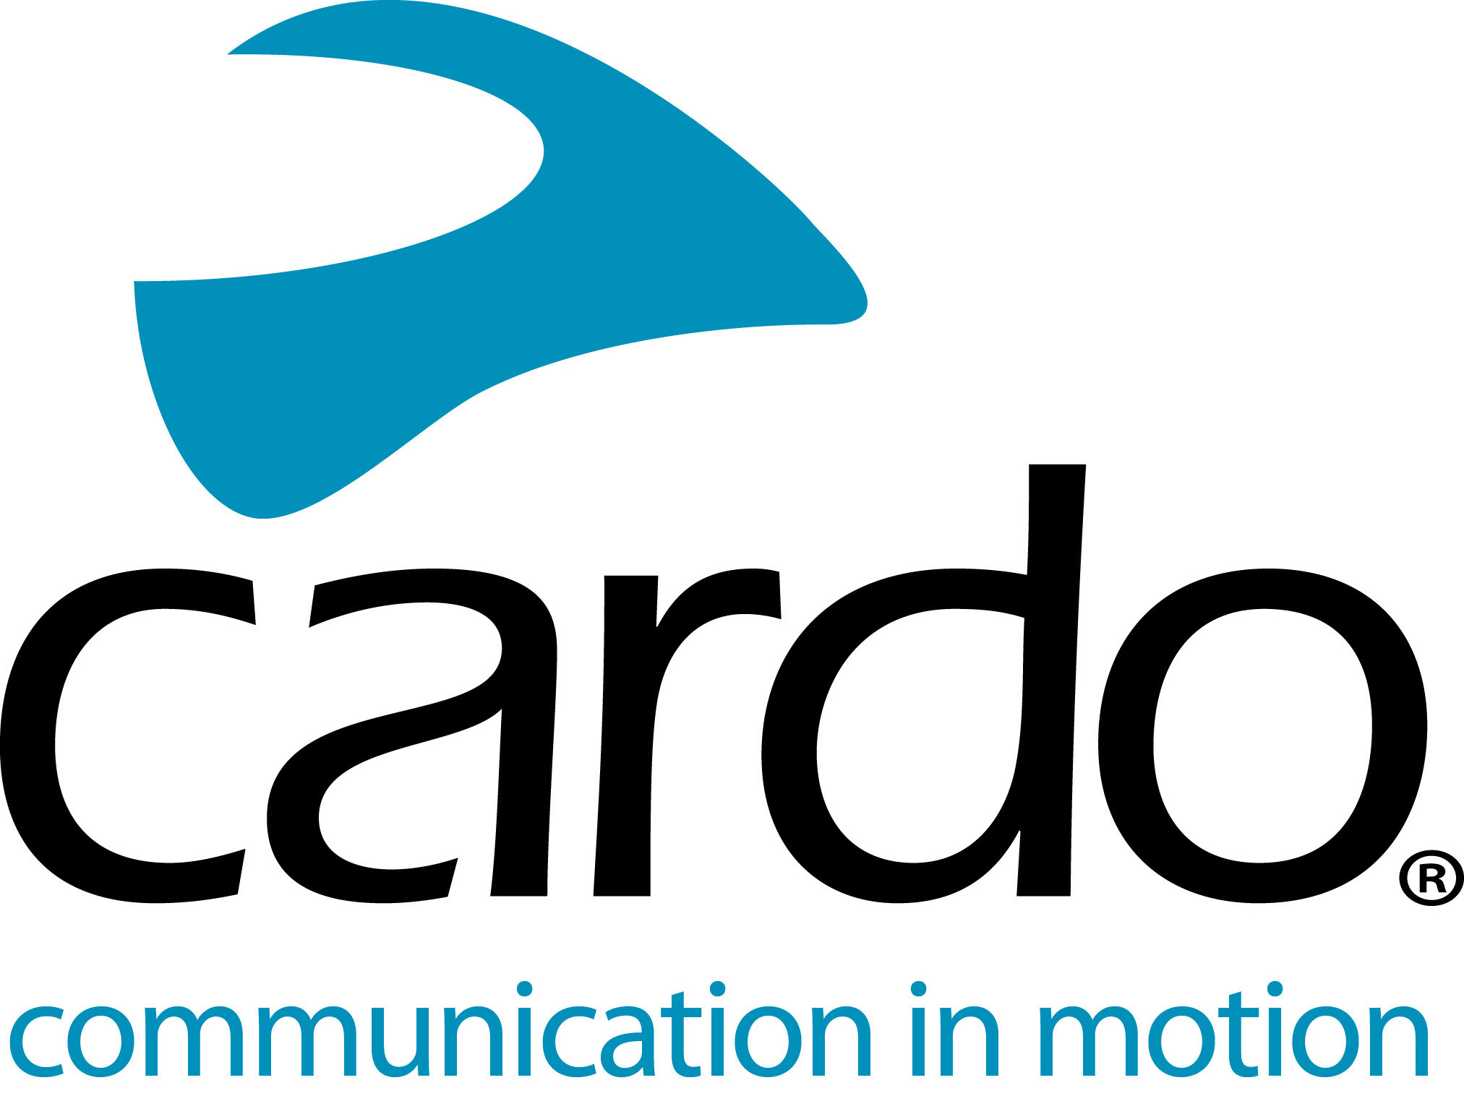

Cardo Systems is proud to support Bella Litinetski in the European custom bike building competition: Petrolettes Wrench-off by Royal Enfield
Italian-based Cardo ambassador, Bella Litinetski, is currently competing in the European-wide Petrolettes Wrench-off with Royal Enfield.
Four teams, across four nations - Italy, Sweden, Germany and Austria - are busy creating custom masterpieces, all of which started life as a Royal Enfield Twin 650. The aim? To create an individual build that embodies their particular expertise and style.
The work-in-progress machines were showcased at the Petrolettes 2019 Festival on 26-28 July in Germany. The finished builds will be revealed at Glemseck 101, Germany (30 August - 1 September) where they will be tested in the sprint races.
Cardo ambassador, Bella Litinetski represents Team Italy with her build ‘Gungnir’, named after the mythological spear that belongs to the god, Odin.
An automotive, product and graphic designer - as well as a motorcycle blogger and journalist - Bella is originally from Israel, but moved to Italy in 2011 to pursue her dream of living a life immersed in motorcycle culture. Her impressive career includes work at the Ducati Design Centre, a thesis in collaboration with Energica as well as contributing to blogs and magazines in Italy, Israel and the US.
“I’m very passionate about bringing more females into motorcycling, as well as bringing those already in it together. A customising project for women is so much needed, and it’s great that Royal Enfield has decided to support female motorcycling and customising culture. I’ve been working with Cardo Systems for a while now and I’d like to thank Cardo Systems for supporting me to take part in this competition. I’m looking forward to racing the bike at Glemseck 101!” comments Bella.
“I did some filming for the Petrolette competition and having the Cardo PACKTALK Bold connected to the director on the phone made it so much easier and safer, especially when coordinating the overtaking of the camera car!”
Bella uses the Cardo Systems IP67 waterproof PACKTALK Bold unit, which features Natural Voice Operation, Dynamic Mesh Communication and JBL speakers.
For more information on the whole Cardo Systems range, visit www.pama.com/cardo or www.cardosystems.com.
Keep up to date with Bella’s progress on her website - www.thebellalit.com - and on Instagram - @thebella.lit
About Cardo
Cardo Systems specialises in the design, development, manufacturing and sale of state-of-the-art communication and entertainment systems for motorcycle helmets. Since inception in 2004, Cardo has pioneered the vast majority of innovations for Bluetooth motorcycle communication systems. The company’s products, now available in over 85 countries, are the world’s leading communication devices for the motorcycle industry.
For press enquiries:
For more information or high resolution images, please contact press@cardosystems.media

