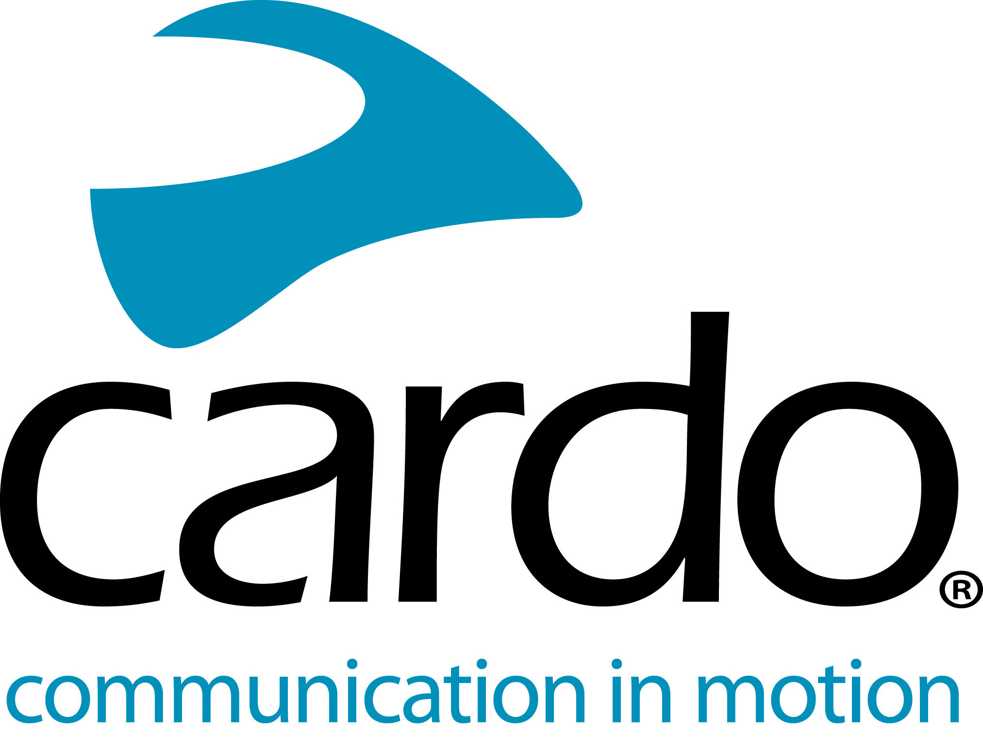

Cardo Systems full range is IP67 waterproof

Riders choosing products from Cardo Systems, the global market leader in wireless communication systems for motorcyclists, can be secure in the knowledge that they can ride in any weather, thanks to the whole range being IP67 waterproof.
“Being riders ourselves, we understand the importance of investing in gear that you can trust. We also understand that the sun isn’t always shining, but that shouldn’t stop you from choosing two wheels. Ever since the launch of our very first motorcycle communications system in 2004, we knew the importance of them being waterproof and have worked to this same aim ever since.”, explains Alon Lumbroso, CEO, Cardo Systems.

The whole Cardo Systems line-up - from the FREECOM1+ to the PACKTALK Bold – has been designed to meet the stringent IP67 waterproof guidelines stating the unit must still work even after being subjected to 30 minutes, one meter underwater.
Through both internal knowledge and expertise, as well as listening to customer feedback, Cardo Systems ensures that their devices can be relied on no matter what the weather. At each step of the development process, every element of the hardware is tested to ensure it complies with the waterproof guidelines, once the unit is complete, it goes through the IP67 testing guidelines.
Head of Product Management at Cardo Systems, Shahar Keren, added: “It is important for us to offer the key features at the highest level we can, which is why it wasn’t good enough for us to simply be water resistant. Just like our partnership with sound experts, JBL, we want the best for our customers.”
The Cardo Systems range includes: FREECOM1+, FREECOM2+, FREECOM4+, PACKTALK Slim and PACKTALK Bold - with prices starting at £129.99. The whole range comes with a two-year warranty.
You can find more information about Cardo Systems at www.pama.com/cardo
Join the conversation on Facebook, Twitter and Instagram.
About Cardo
Cardo Systems specialises in the design, development, manufacturing and sale of state-of-the-art communication and entertainment systems for motorcycle helmets. Since inception in 2004, Cardo has pioneered the vast majority of innovations for Bluetooth motorcycle communication systems. The company’s products are the world’s leading communication devices for the motorcycle industry and are available in over 85 countries.
For press enquiries:
For more information on the FREECOM+ line of products and for high resolution images please contact press@cardosystems.media | www.cardosystems.com

