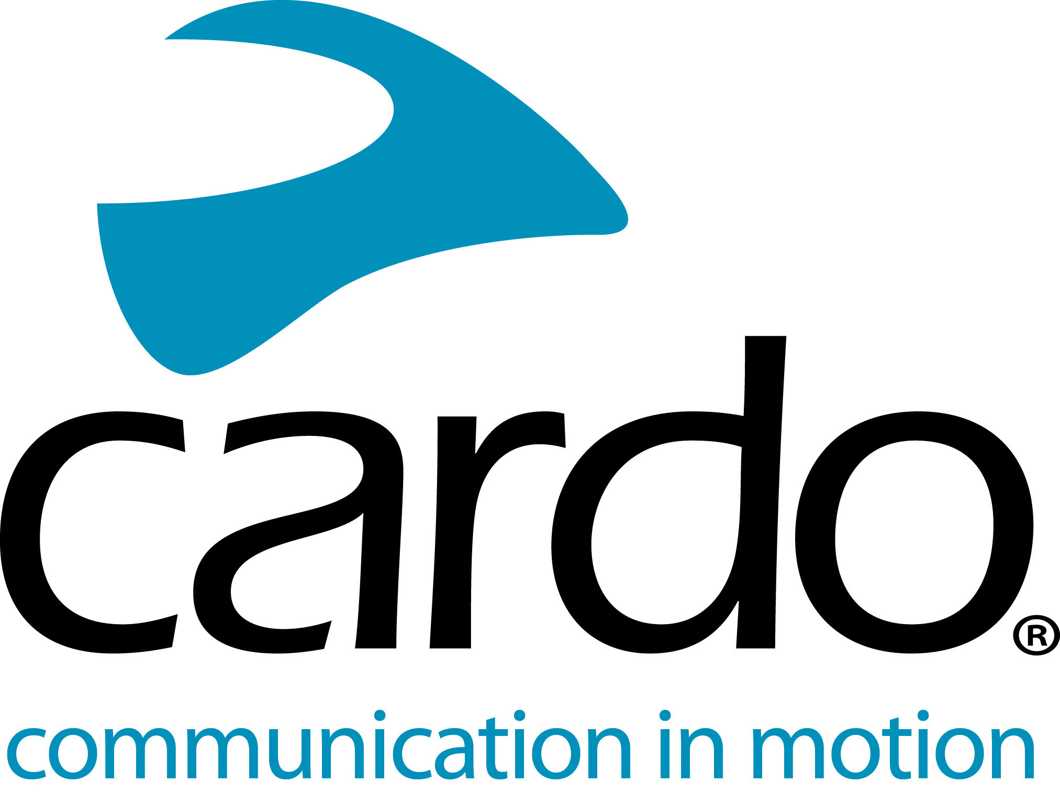

Cardo Systems FREECOM1+ - offering premium features for all riders...

The world’s best selling single rider Bluetooth headset, the FREECOM1+, is equipped with rider-to-passenger capabilities for the same price point as its predecessor, the FREECOM1, in 2019. But this is just one of the reasons motorcyclists across the globe choose the Cardo Systems unit over other devices on the market. Here are even more reasons that prove customers don’t have to settle for second best…

Easy installation and set up

The benefits start as soon as customers take the FREECOM1+ out of the box, as it requires no screws or tools for installation and is compatible with all helmets.

Waterproof

The whole Cardo Systems range is IP67 waterproof - not just water resistant like some other devices - ride with complete confidence in any weather conditions.

Future-proof

The FREECOM1+ has future-proof firmware, thanks to being fully supported with future updates from Cardo Systems, the global market leader in wireless communication systems for motorcyclists.

Extensive battery life

With a 13-hour battery life, and the ability to be charged on the go, the FREECOM1+ has almost double the battery life of one of its competitors.

Great sound

The sound quality offered by the 40mm speakers included in the box offers great sound quality, but for motorcyclists wanting the ‘Ultimate Sound Experience’, the FREECOM1+ is compatible with the JBL Audio Set. The 45mm speakers - which have a 42mm base to fit in most modern helmets - provide deeper bass and a rounder overall sound.

App-equipped

The entire FREECOM+ and PACKTALK ranges can be controlled using Cardo’s new mobile app, Cardo Connect™. Free to download, the app has been designed for a smooth user experience and shows a dashboard of information associated with the connected Cardo device.

Premium features as standard

The FREECOM1+ features a built-in FM radio as standard - no need for a special edition - as well as microphone noise reduction and Automatic Volume Control so there’s no need to manually change the volume when changing speeds.

The FREECOM 1+ has a Manufacturer’s Suggested Retail Price (MSRP) of £129.99 for a single unit – a duo pack is also available with a MSRP of £240.99.

www.pama.com/cardo

You can find more information about Cardo Systems at www.cardosystems.com. Join the conversation on Facebook, Twitter and Instagram.

About Cardo

Cardo Systems specialises in the design, development, manufacturing and sale of state-of-the-art communication and entertainment systems for motorcycle helmets. Since inception in 2002, Cardo has pioneered the vast majority of innovations for Bluetooth motorcycle communication systems. The company’s products, now available in over 85 countries, are the world’s leading communication devices for the motorcycle industry.

For press enquiries:

For more information on the FREECOM+ line of products and for high resolution images please contact press@cardosystems.media | www.cardosystems.com

