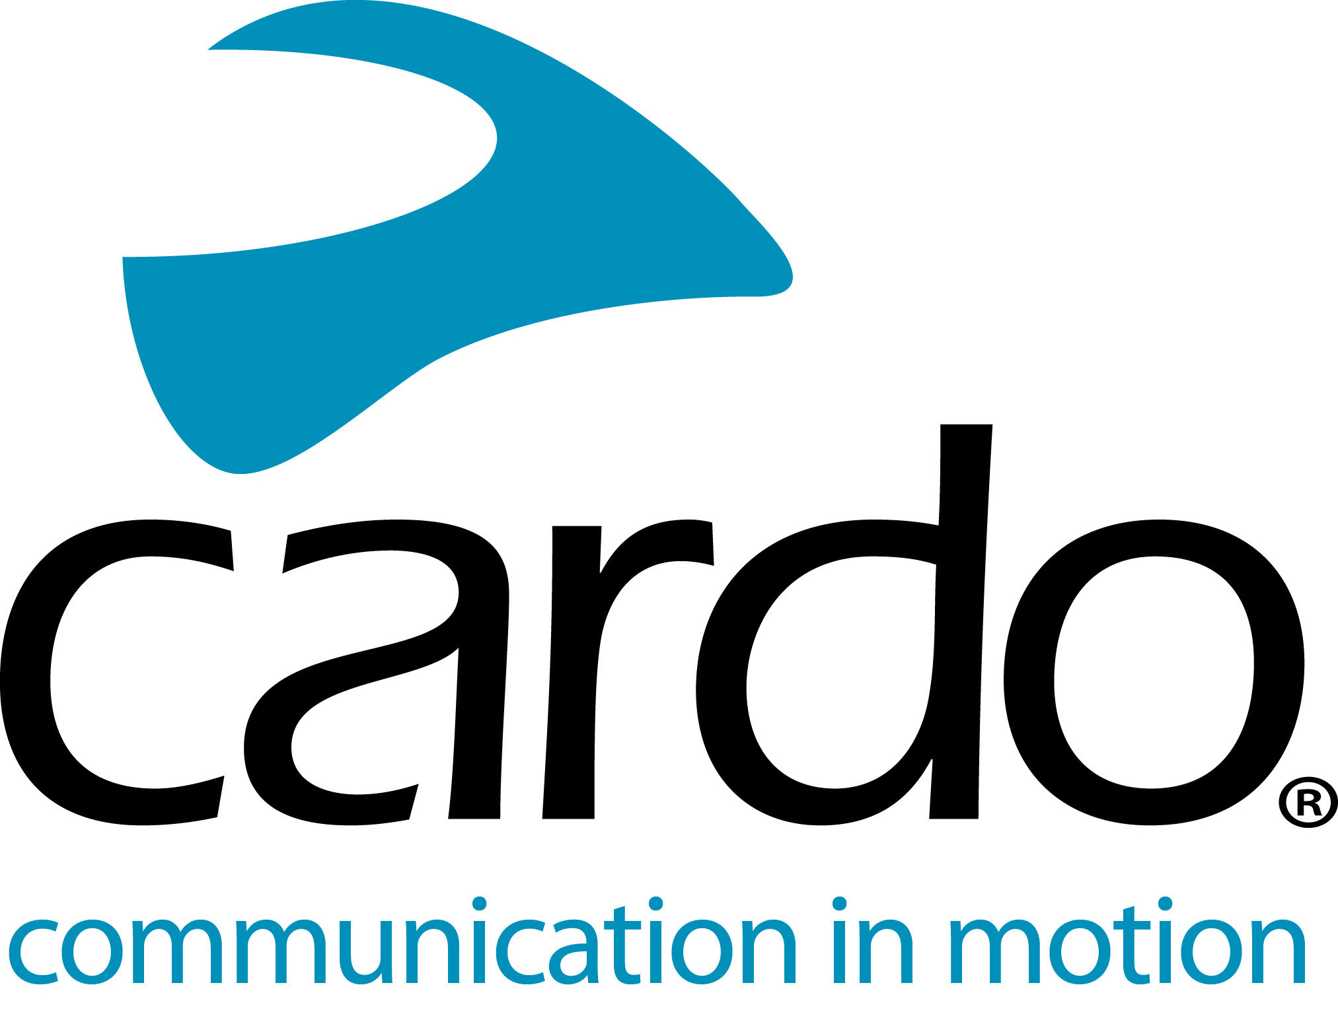

Cardo Systems focus on off-road communication

Riding off-road has long been an experience better shared, but until now communication has rarely extended past a knowing nod, shake of the head or distant shout. Thanks to Cardo Systems that’s now just a memory thanks to their waterproof range of communication devices, including the PACKTALK Bold, ideal for the casual trail rider or extreme enduro competitor.
Small and tough, the communication system is designed to be completely intuitive with easy on-trail operation, allowing riders to chat in a group*, get audible directions or even listen to music.
Key features making the Cardo PACKTALK Bold, THE choice for off-road riders, include:
- Off-road ready - IP67 dustproof, mudproof and waterproof - the whole Cardo Systems range is waterproof, not just water-resistant, so riders can trust their Cardo unit to keep them connected no matter how big the water crossing is or how high the mud.
- ‘Set-and-forget’ Dynamic Mesh Communication connectivity - once the PACKTALK BOLD units have been paired together, then if you ride together again, they’ll remember. Riding off-road, riders are often in and out of the range of the units, but with DMC riders don’t need to reconnect as it’s done automatically without needing to press any buttons.
- JBL speakers - experience the ‘Ultimate Sound Experience’ thanks to the JBL speakers that come as standard with the PACKTALK range. Also available is a JBL Audio Set which is compatible with Cardo’s full range of legacy products, as well as products from other motorcycle communication brands, which are equipped with a standard 3.5mm jack.
- Natural Voice Operation - there’s no need for riders to take their hands off the bars, they can simply say “Hey Cardo” and the device reacts instantly to follow the given command, without the rider having to press any buttons - useful when warning a friend of a tricky section of trail or obstacle The technology seamlessly integrates with Apple’s Siri™ and “OK Google”™ voice-command platforms too.
- Automatic volume adjustment - sound volume is automatically adjusted based on the outside ambient noise.
- 13-hour battery life - all units have an average battery life of 13 hours and can also be charged while riding - more than enough for a day on the trail.
The entire PACKTALK ranges can be controlled using Cardo’s new mobile app, Cardo Connect™. Free to download, the app has been designed for a smooth user experience and shows a dashboard of information associated with the connected Cardo device. Users can create ‘groups’ of riders, manage their favourite radio stations, configure phone speed dials, control settings, adjust volumes and see the units battery status at a glance.
For more information and to see the whole product range, visit Cardo Systems at www.pama.com/cardo and join the conversation on Facebook, Twitter and Instagram.
*The PACKTALK Bold can connect 2-15 riders.
About Cardo
Cardo Systems specialises in the design, development, manufacturing and sale of state-of-the-art communication and entertainment systems for motorcycle helmets. Since inception in 2004, Cardo has pioneered the vast majority of innovations for Bluetooth motorcycle communication systems. The company’s products, now available in over 85 countries, are the world’s leading communication devices for the motorcycle industry.
For more information on Cardo System and its line of products, please contact press@cardosystems.media | www.cardosystems.com
Photo credit: @alexey13kolesnikov

