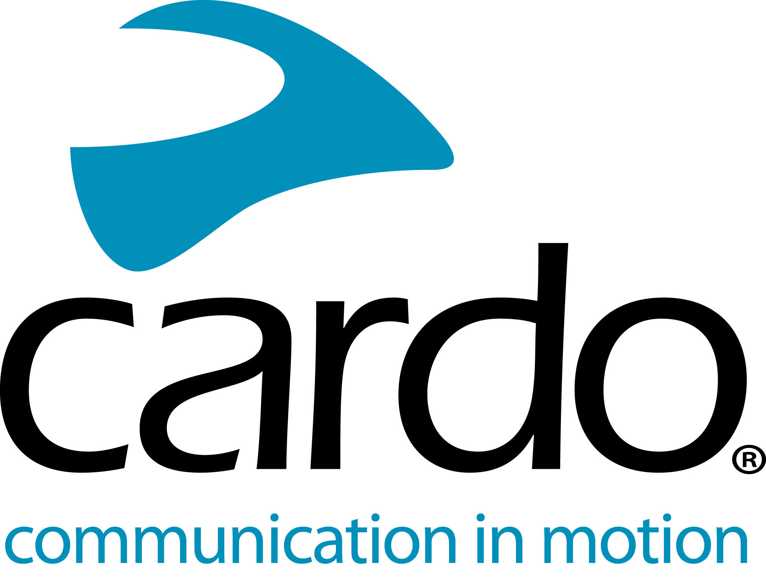

Cardo Systems becomes MotoAmerica series sponsor for the 2020 season
Cardo Systems is proud to be MotoAmerica series sponsor for the 2020 season with the road racing series - a partnership set to showcase its advanced motorcycle communications technology to the MotoAmerica viewing audience.
The organization that promotes the AMA Superbike Series and has done since 2015, MotoAmerica is sanctioned by the American Motorcyclist Association and the Fédération Internationale de Motocyclisme. There are five classes of road racing in the series, including Superbike, Stock 1000, Supersport, Twins and the Liqui Moly Junior Cup.
Cardo Systems specialises in the design, development, manufacturing and sale of state-of-the-art wireless communication and entertainment systems for motorcycle riders. Since inception in 2004, Cardo has pioneered the vast majority of innovations for Bluetooth motorcycle communication systems. The company’s products, now available in over 100 countries, are the world’s leading communication devices for the motorcycle industry.
MotoAmerica’s Lance Bryson said: "It’s great to have Cardo Systems involved in our series as a sponsor, but it goes deeper than that as we will be able to showcase their products to our audience by actually showing Cardo’s technology and how it is used by incorporating it into our broadcast and MotoAmerica Live+ programming."
Jamie Cheek, VP of Sales North America for Cardo added: "We at Cardo are extremely excited to partner with MotoAmerica. We look forward to continuing our involvement with such an outstanding group in our industry."
For information on how to watch the MotoAmerica Series, click HERE
For the full 2020 MotoAmerica Series schedule, click HERE
Join the conversation and the #CardoFam on Facebook, Twitter and Instagram.

