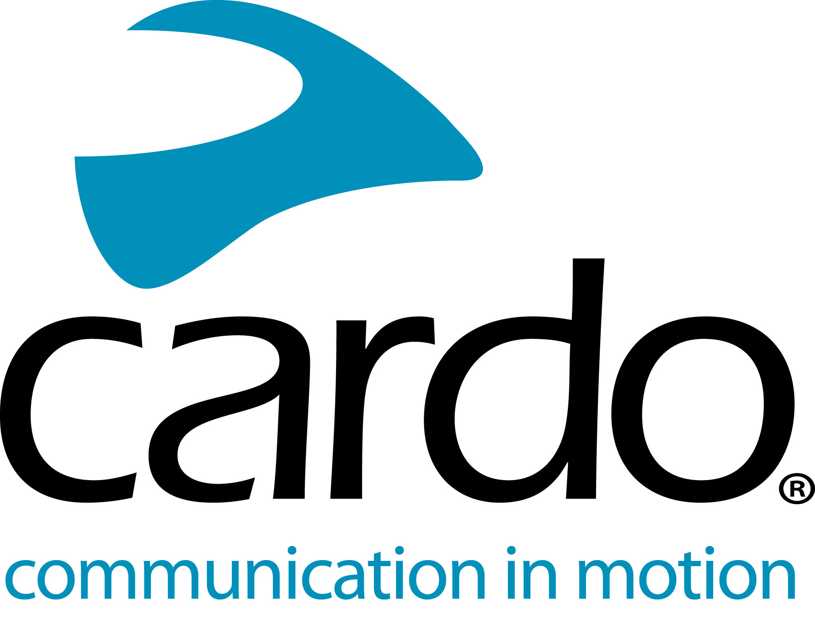

Cardo Systems - allowing commuters to stay isolated, but stay connected
Due to the current COVID-19 pandemic, it’s understandable that many commuters are looking for an alternative to busy public transport. Not wanting to pack onto busy buses and stuffy trains, many are looking to two-wheels as an alternative method of transport for getting from A to B.
Travelling on a powered two-wheeler boasts a number of advantages - the ability to be socially distant and isolation being key. However, just because commuters are ‘isolated’, it doesn’t mean they can’t stay connected and need to give up some of their home comforts.
Whether it be travelling somewhere new and needing sat-nav instructions, communicating with family and friends via phone, catching up on the news on FM radio or singing along to their favourite songs via music streaming service - riders can do it all using Cardo Systems. If riding with someone else from your household or as a pillion, the unit-to-unit intercom allows riders to communicate in real time - and up to one mile apart*.
Purposefully designed for motorcycling use, there’s a Cardo System for all price ranges. The line-up consists of the FREECOM1+, FREECOM2+, FREECOM4+, PACKTALK Slim and PACKTALK bold - with prices starting from €139.95/£129.99, riders can choose the right unit for them and their needs. There’s even a handy quiz on the Cardo Systems website - www.cardosystems.com - to help you choose by answering a few simple questions. The one common denominator about them all? They come from the world’s leading communication devices for the motorcycle industry backed by over 15 years experience.
The whole range is waterproof, boasts a 13-hour battery life and comes with a two-year warranty and automatic volume control. The FREECOM4+ and PACKTALK units have Natural Voice Operation with direct access to ‘Hey Siri’ and ‘OK Google’, so riders don’t need to take their hands off the bars for tasks such as answering calls.
Find more information about Cardo Systems at www.cardosystems.com.
Join the conversation on Facebook, Twitter and Instagram.
*PACKTALK Bold or PACKTALK Slim in perfect conditions connected using Dynamic Mesh Communication.
About Cardo
Cardo Systems specialises in the design, development, manufacturing and sale of state-of-the-art wireless communication and entertainment systems for motorcycle riders. Since inception in 2004, Cardo has pioneered the vast majority of innovations for Bluetooth motorcycle communication systems. The company’s products, now available in over 100 countries, are the world’s leading communication devices for the motorcycle industry.

