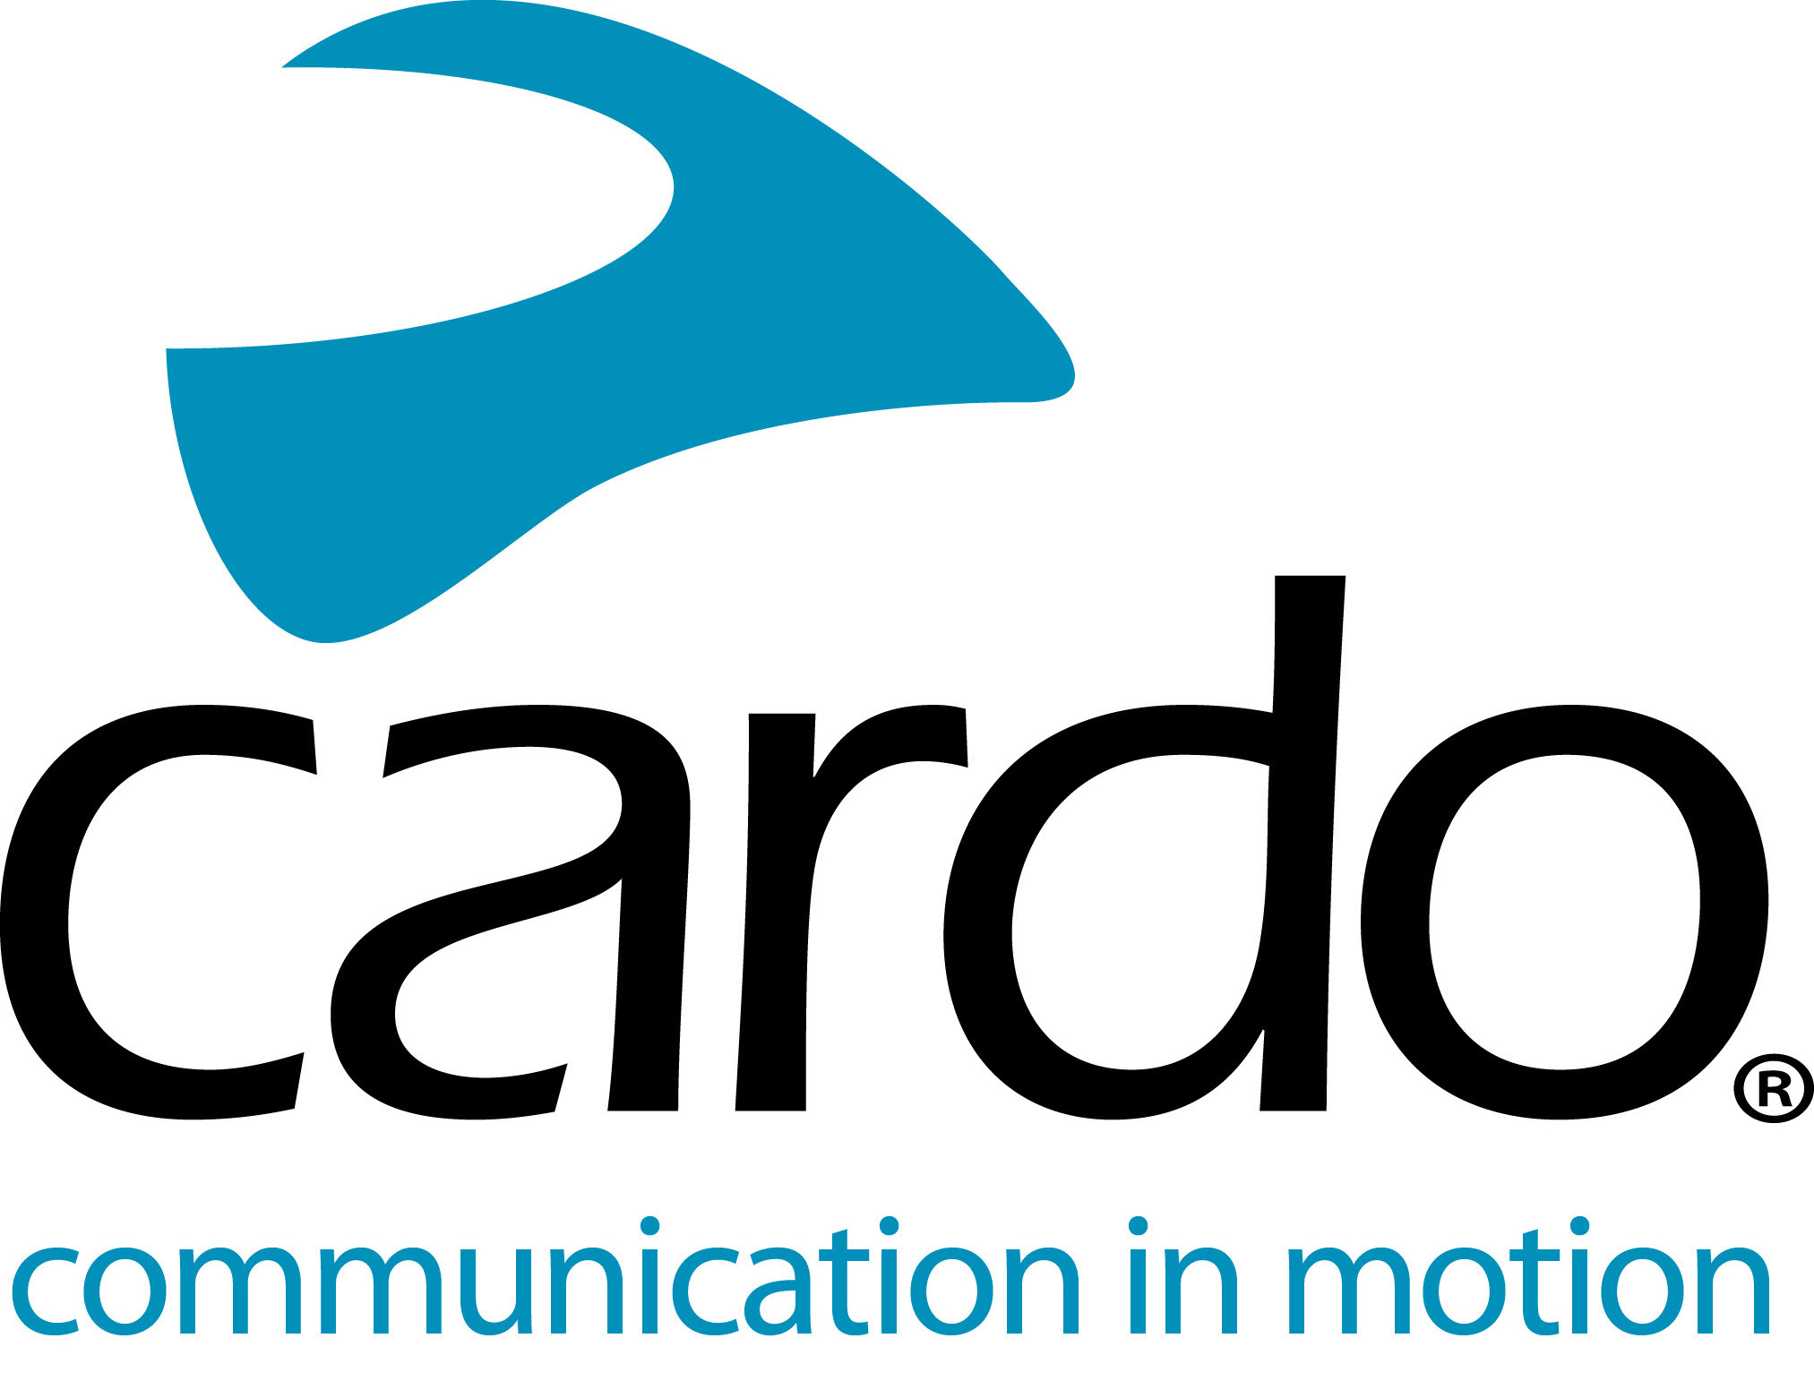

Cardo Systems adds new value to the Bluetooth category with an entirely redesigned FREECOM+ Lineup

Cardo Systems, the global market leader in wireless communication systems for motorcyclists, today unveiled the redesigned FREECOM+ line. Available at speciality retailers and Cardosystems.com, the Cardo FREECOM 4+, FREECOM 2+ and FREECOM 1+ deliver new premium features to the four-way rider-to-rider, rider-to-passenger and single-rider categories while maintaining an affordable price point for the best-performing Bluetooth communication systems in the world.
Announced at EICMA in November, the FREECOM 4+ adds new value to midrange Bluetooth motorcycle communication systems, with premium features such as Natural Voice Operation and JBL Sound. Utilizing a new, redesigned shell, FREECOM 4+ sports a cutting-edge aerodynamic and ergonomic design with a razor-thin and clickable roller wheel.
FREECOM 4+ single sound profile offers the purest audio experience designed and perfected in JBL’s Los Angeles audio labs. Natural voice-command operation allows riders to simply say, “Hey Cardo” without having to press any buttons, and the always-on device reacts instantaneously. Additionally, the technology seamlessly integrates with Apple’s Siri™ and “OK Google”™ voice-command platforms.
Cardo FREECOM 2+ adds range to the two-way rider-to-rider category with a 500m/0.3mi bike-to bike intercom. Cardo FREECOM 1+, the redesign of the world’s best selling single rider Bluetooth headset, adds rider-to-passenger capabilities at the same price point for an incredible entry-level package.
“Our goal is to enhance the riding experience through advance technology across all product lines and offer the best-in-class Bluetooth communication system, at a reasonable price” said Dr. Abraham Glezerman, founder and CEO of Cardo Systems. “The redesigned and reloaded FREECOM+ lineup offers riders improved way to communicate with a product they already know and trust.”
FREECOM 4+ (€249.95 MSRP Single)
The FREECOM 4+ represents all of PACKTALK’s premium features in a Bluetooth system to create the best Bluetooth communication device in the world. Connect one to four riders with up to three-fourths mile range, experience Sound by JBL and easy-to-use natural voice operation, Bluetooth 4.1, and universal connectivity.
FREECOM 2+ (€169.95 MSRP Single)
FREECOM 2+ adds more punch with true rider-to-rider capabilities. Connect one to two riders with one-third mile two-way intercom, Bluetooth 4.1, immersive sound from 40mm HD speakers, and universal connectivity.
FREECOM 1+ (€139.95 MSRP Single)
FREECOM 1+ is the world’s most advanced single-rider Bluetooth headset now with rider-to-passenger functionality. The system features immersive sound with 40mm speakers, Bluetooth 4.1 and universal connectivity.
Cardo Connect™ is Cardo’s new intuitive mobile app for setting and controlling the entire FREECOM+ and PACKTALK line of devices on the road. Its clean, clear and contemporary design make it easy to use and the riding mode includes all essential functions for a smooth user experience.
All Cardo units are IP-67 waterproof, not simply water-resistant like lesser communicators, and all feature a two-year warranty and a U.S.-based customer-support system.

Note to Editors:
The FREECOM+ line will be available in Europe from 7th January, and available in North America from 14th January.
You can find more information about Cardo Systems at www.cardosystems.com. Also visit us and join the conversation on Facebook, Twitter and Instagram.
About Cardo
Cardo Systems specialises in the design, development, manufacturing and sale of state-of-the-art communication and entertainment systems for motorcycle helmets. Since inception in 2004, Cardo has pioneered the vast majority of innovations for Bluetooth motorcycle communication systems. The company’s products, now available in over 85 countries, are the world’s leading communication devices for the motorcycle industry.
For press enquiries:
For more information on the FREECOM+ line of products and for high resolution images please contact press@cardosystems.media | www.cardosystems.com

