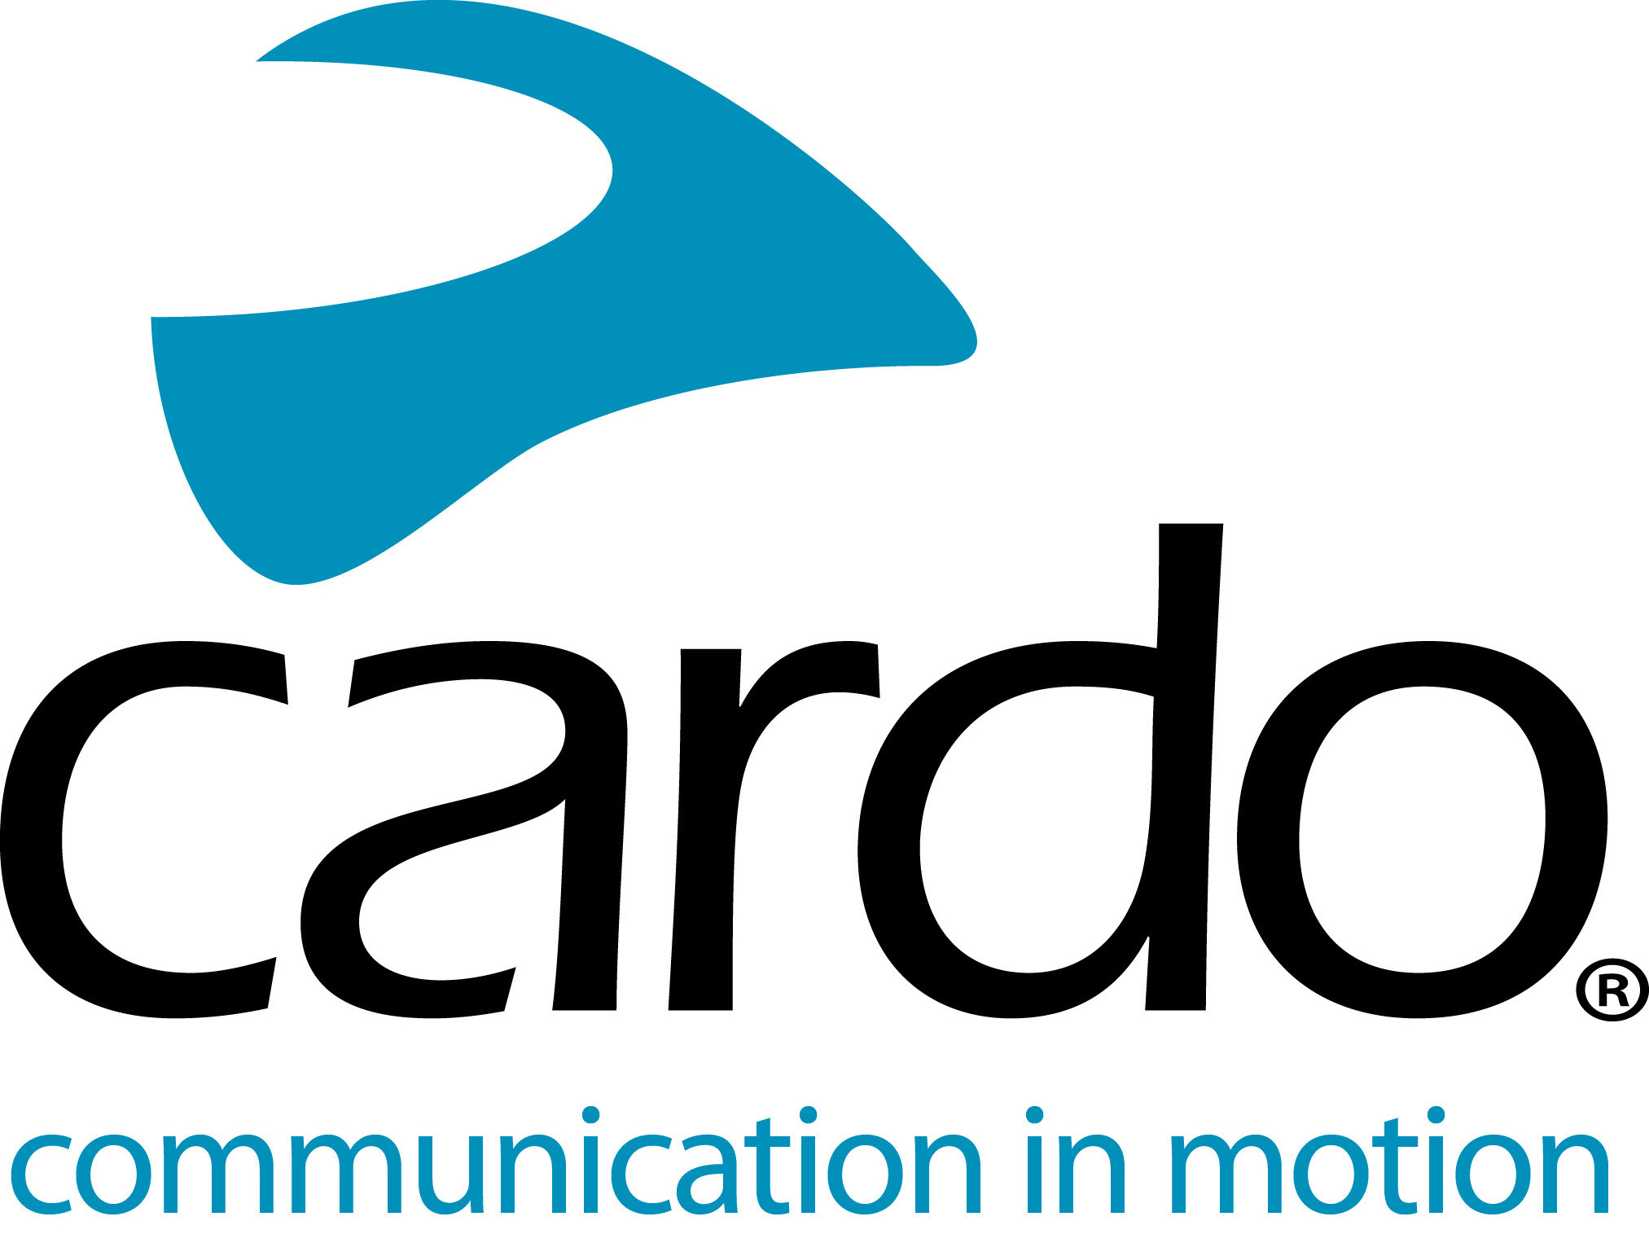

Cardo Systems - a Producer’s best friend

Out in the wilderness, surrounded by stunning scenery and attempting to communicate with the main star of the video who is wearing a helmet can present quite the challenge. However, by kitting up the rider with a Cardo Systems PACKTALK Bold makes the job much easier.
Javi Echevarría is the Producer and Photographer behind ‘The Seeker’, a short film featuring trials champion and enduro riding star Pol Tarres performing a myriad of mind-bending manoeuvres on a stock Yamaha Tenere 700.
“This is the first time I used the Cardo Systems PACKTALK units during a shoot and it is now a must for our next productions. On the shoot, there is not a lot of time so the fact that the units were so easy to use and connect made a real difference.”
Communication between the rider and the Director is key in video shoots and traditionally the rider would have to come back to the production team after every shot, turn off the engine, and speak face to face, so using the PACKTALK units, it saved a lot of time on location. While Pol's helmet was fitted with the PACKTALK Bold, Javi used a set of the demo PACKTALK headphones from Cardo, with a Bold unit clipped in.
“We definitely gained a lot of productivity because of the perfect communication with the rider and saved much time and energy. The most challenging locations are always the ones where the rider is far away from us because coordination is hard when we do camera car shots. Communication with Pol is very important to get the shots in the least amount of time as possible. Without the Cardo, we probably needed double the amount of time to get those shots.
“The sound from them was so clear and, for sure, one of the main benefits was to have my hands free to manipulate my camera.”
The shoot itself was completed over seven days in a row across a variety of locations. Something the 13-hour battery life of the Cardo System came in handy for as the team only had to charge them once a day.
Working in such vast spaces too meant that sometimes the team would be out of the one-mile range of the PACKTALK unit, however, due to the Dynamic Mesh Communication (DMC) connectivity, they didn’t need to worry about reconnecting, as it just happened automatically.
Here’s the video in full: https://youtu.be/eDxBGc9TD4c
To find out more about the Cardo Systems line-up, visit www.cardosystems.com or contact your local distributor – www.pama.com/Cardo. To join the conversation, follow along on the Cardo Systems Facebook, Twitter and Instagram channels or check out the YouTube channel.
Photo credit: @livelike_javi_thewho
About Cardo
Cardo Systems specialises in the design, development, manufacturing and sale of state-of-the-art wireless communication and entertainment systems for motorcycle riders. Since inception in 2004, Cardo has pioneered the vast majority of innovations for Bluetooth motorcycle communication systems. The company’s products, now available in over 100 countries, are the world’s leading communication devices for the motorcycle industry.

