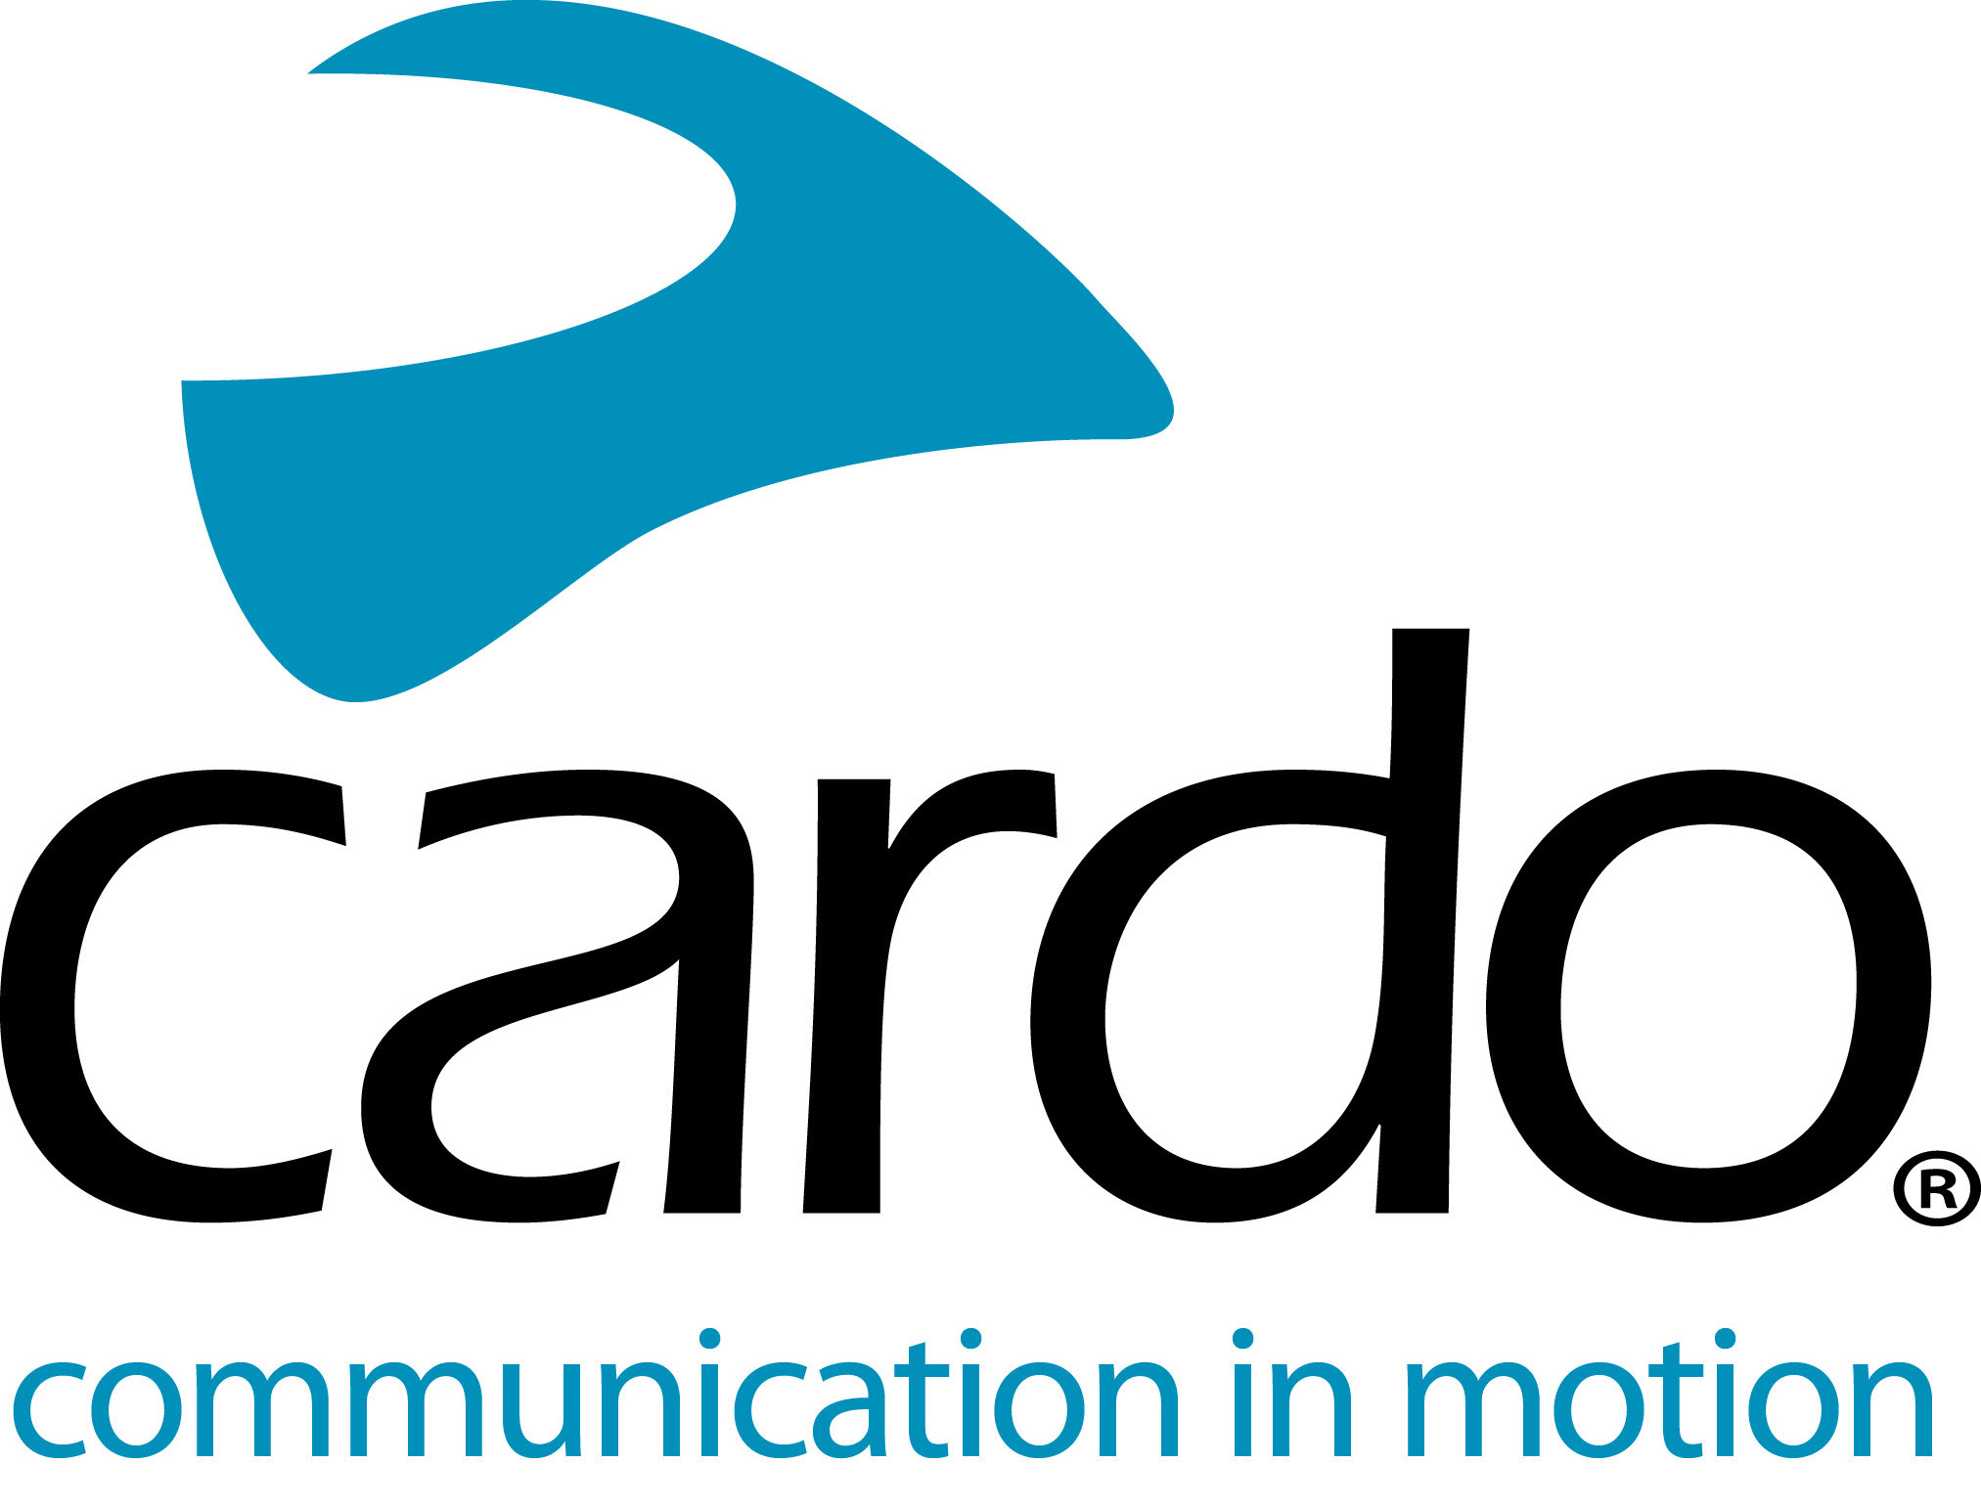

Cardo, Midland, Uclear, and Sygn House team up to create an industry standard for integrated helmet communications
The four companies jointly announce UNIVERSAL COMMUNICATION SOLUTION for industry-wide interoperable helmet communications.
Cardo Systems, Midland, Uclear and Sygn House (owners of the B+Com brand) have today announced an industry-wide solution to integrated helmet communication devices – ‘Universal Communication Solution’.
Much in the same way that the Automakers and car stereo manufacturers adopted universal car stereo sizing and mounts (DIN/Double DIN Standard), the Universal Communication Solution standardizes communication systems size, and shape, allowing for integrated fitment in new motorcycle helmets, meeting the new ECE 22.06 standards.
With this new standard in place, Helmet manufacturers can potentially speed up the process of integrating communications into new 22.06 helmets while offering motorcyclists a variety of communication brands to choose from, all while reducing development costs and time to market.
The Universal Communication Solution will also allow motorcyclists the freedom to choose, change and replace communication devices without compromising on fit and looks.
Speaking on behalf of the industry, Shachar Harari, VP business development at Cardo Systems commented, “This is a significant and important initiative that has seen collaboration between many of the key manufacturers in the helmet and communications industry.
This alliance between the companies will enable the supply of a variety of communication systems that are compatible and designed to be integrated with a variety of motorcycle helmet brands without any need for special mechanical adjustment per helmet model.
We call the helmet manufacturers to join forces with us and design their helmet offerings to adopt the Universal Communication Solution standard.”
While many helmet manufacturers have experienced demand for integrated communication solutions, until now this has been a significant R&D effort for each brand without a widely acceptable standard solution and without the advantage of duplicating this effort to new helmets. With the Universal Communication Solution, consumers will potentially be able to select their preferred brand of device, mounting the chosen unit cradle into a standardized cavity in the rear section of the helmet, linking to integrated speakers and microphone.
Shachar continued, “This approach also gives consumers choice, allowing the rider to use their preferred brand of system and easily transfer between helmets if required. We encourage other brands to join us and adopt the industry-wide Universal Communication Solution”.
Further details and an updated timeline for this project will be published at a later date. For more information or to organise media interviews, please contact the Cardo Systems EMEA Press Office at press@cardosystems.media or call +44(0) 1525 270100 - www.cardosystems.media, or Ms. Dora Mantovani, Marketing Manager, dmantovani@midlandeurope.com – (+39) 0522. 509411

